Phase 4 part A
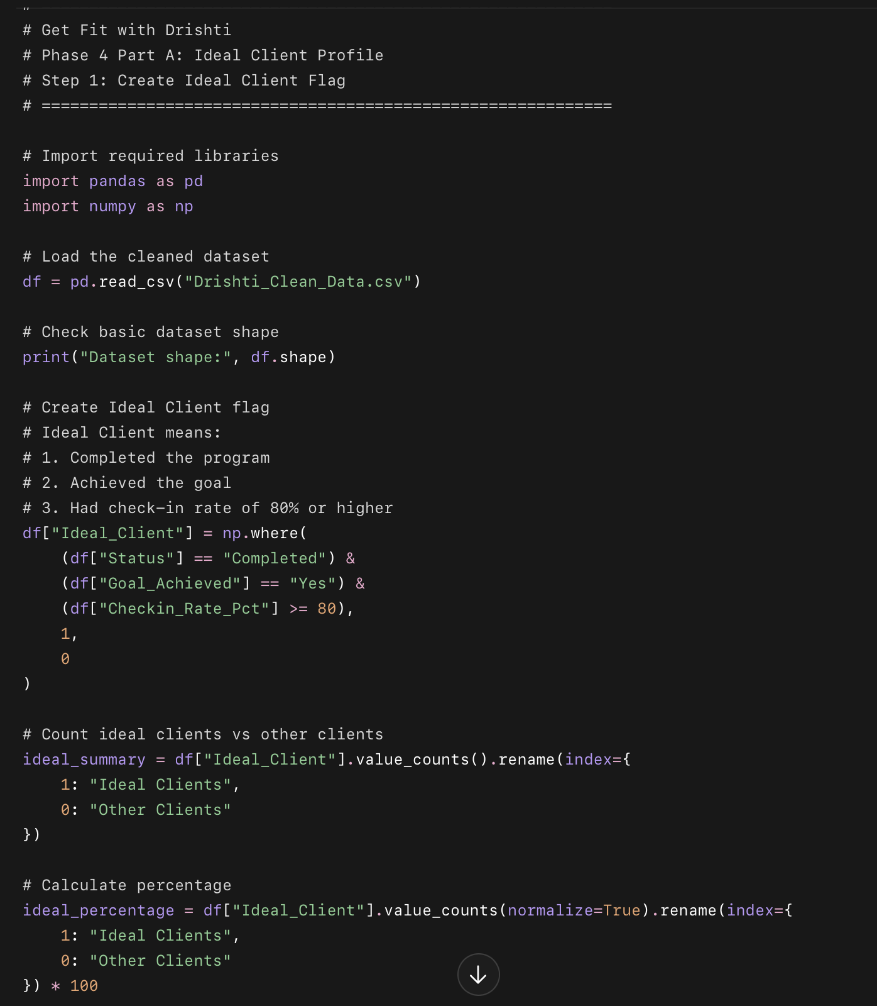
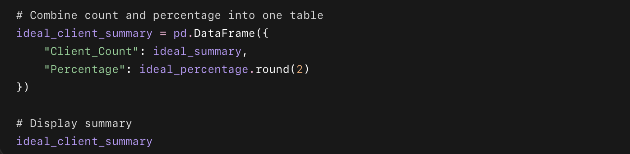

What this code does
- Loads your cleaned dataset.
- Creates a new column called Ideal_Client.
- Marks a client as 1 if they:
  - completed the program,
  - achieved their goal,
  - had at least 80% check-in rate.
- Marks everyone else as 0.
- Shows how many ideal clients exist in the full dataset.

Step 2: Compare Ideal Clients vs Other Clients for Categorical Columns
Now we’ll compare what ideal clients look like across text/category columns like gender, country, goal type, lead source, diet type, motivation level, etc.
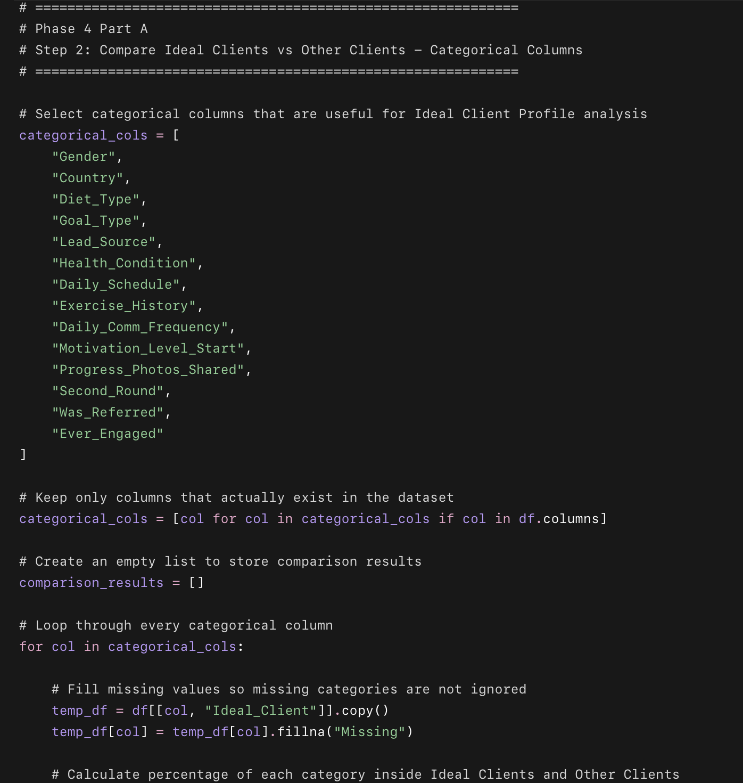
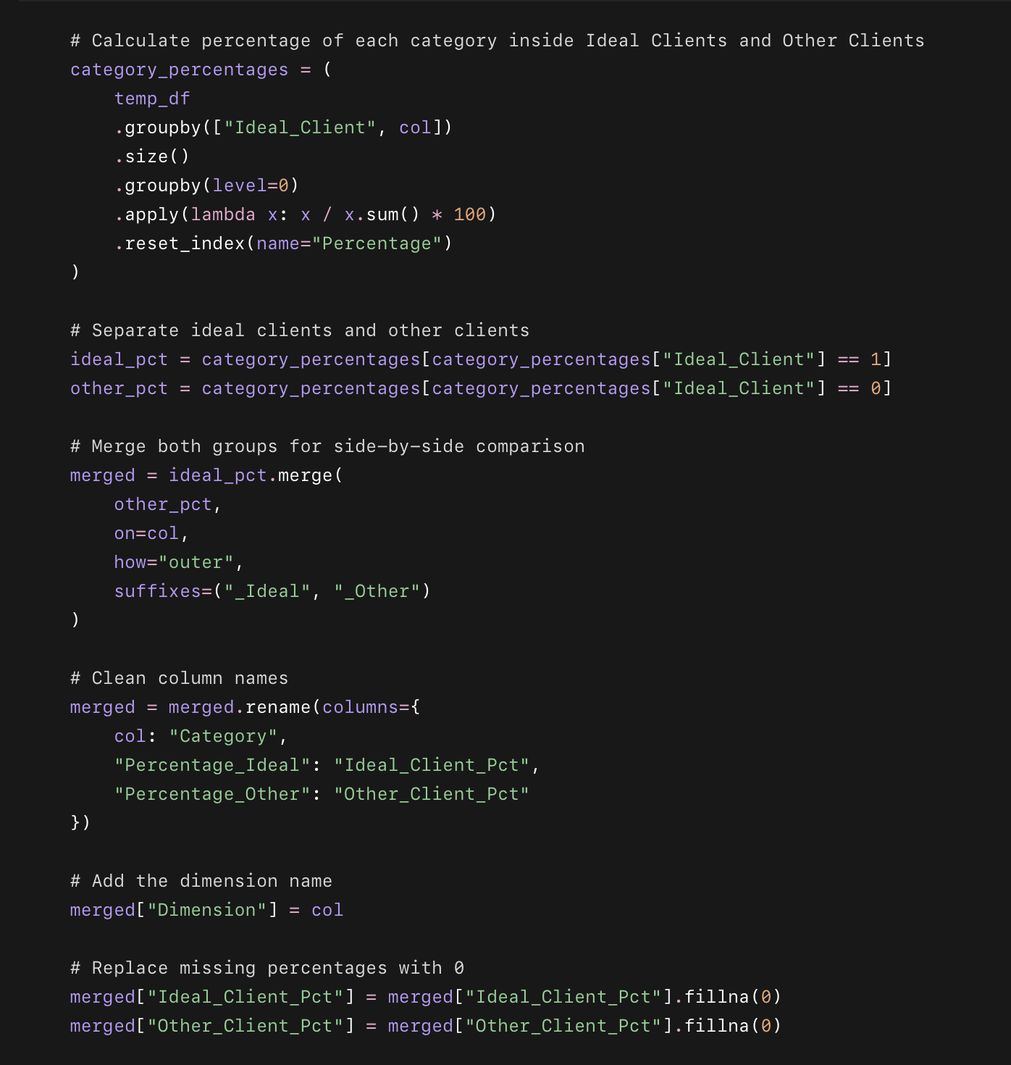
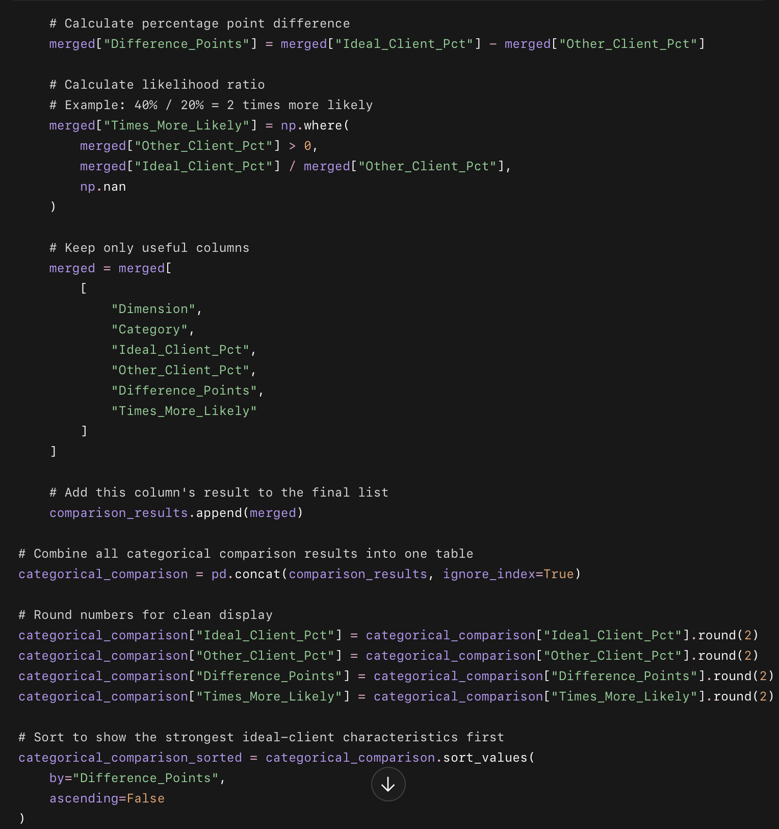
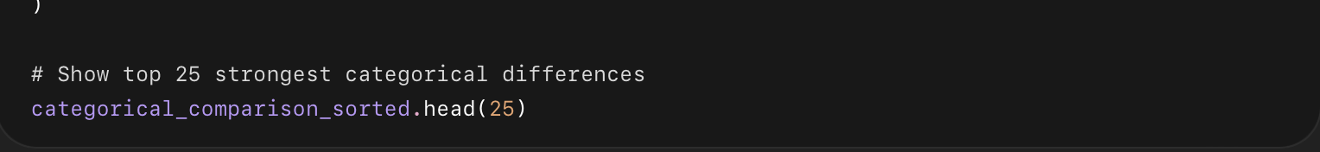

What this code does
- Looks at important categorical columns like Gender, Country, Goal_Type, Lead_Source, and Motivation_Level_Start.
- Compares Ideal Clients vs Other Clients.
- Calculates:
  - percentage of ideal clients in each category,
  - percentage of other clients in each category,
  - difference in percentage points,
  - how many times more likely ideal clients are to have that characteristic.
- Sorts the table so the strongest ideal-client patterns appear first.

Step 3: Compare Ideal Clients vs Other Clients for Numeric Columns
Now we’ll compare numbers like:
Age
Goal_Gap_kg
Payment_Speed_Days
Days_To_First_Engagement
Checkin_Rate_Pct
Weekly_Checkins_Completed
Program_Duration_Days
Revenue_USD
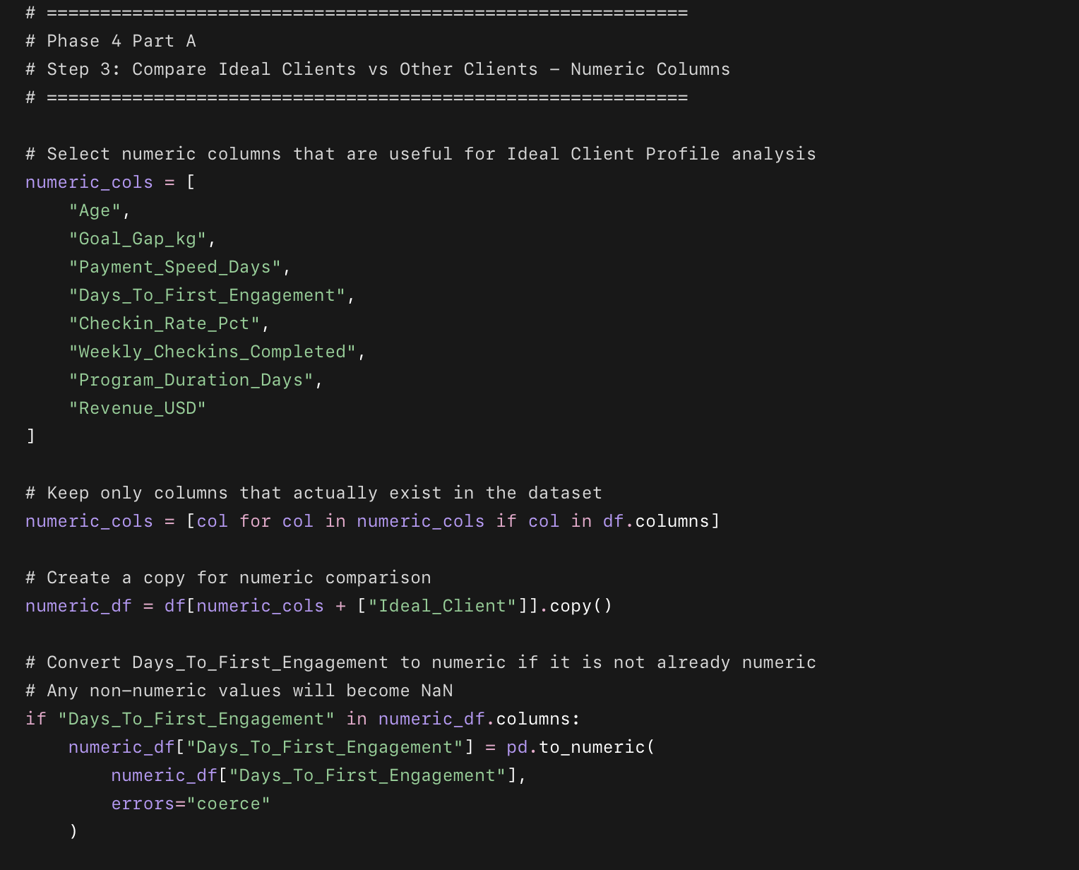
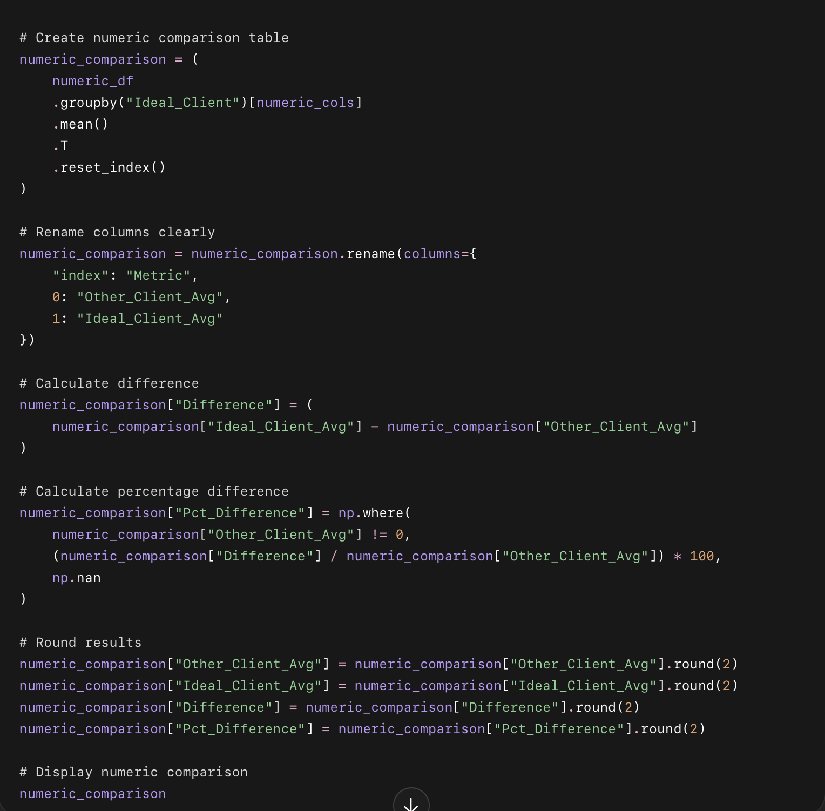

What this code does
- Compares average numeric values between Ideal Clients and Other Clients.
- Shows whether ideal clients are older/younger.
- Shows whether they pay faster.
- Shows whether they engage sooner.
- Shows whether they complete more check-ins.
- Shows how much better their check-in rate is.
- Converts Days_To_First_Engagement into a number if needed.

Part A

Step 4: Generate Insight Sentences Automatically
Now we’ll turn your comparison table into clean business sentences like:
Ideal clients are 1.39 times more likely to share progress photos.
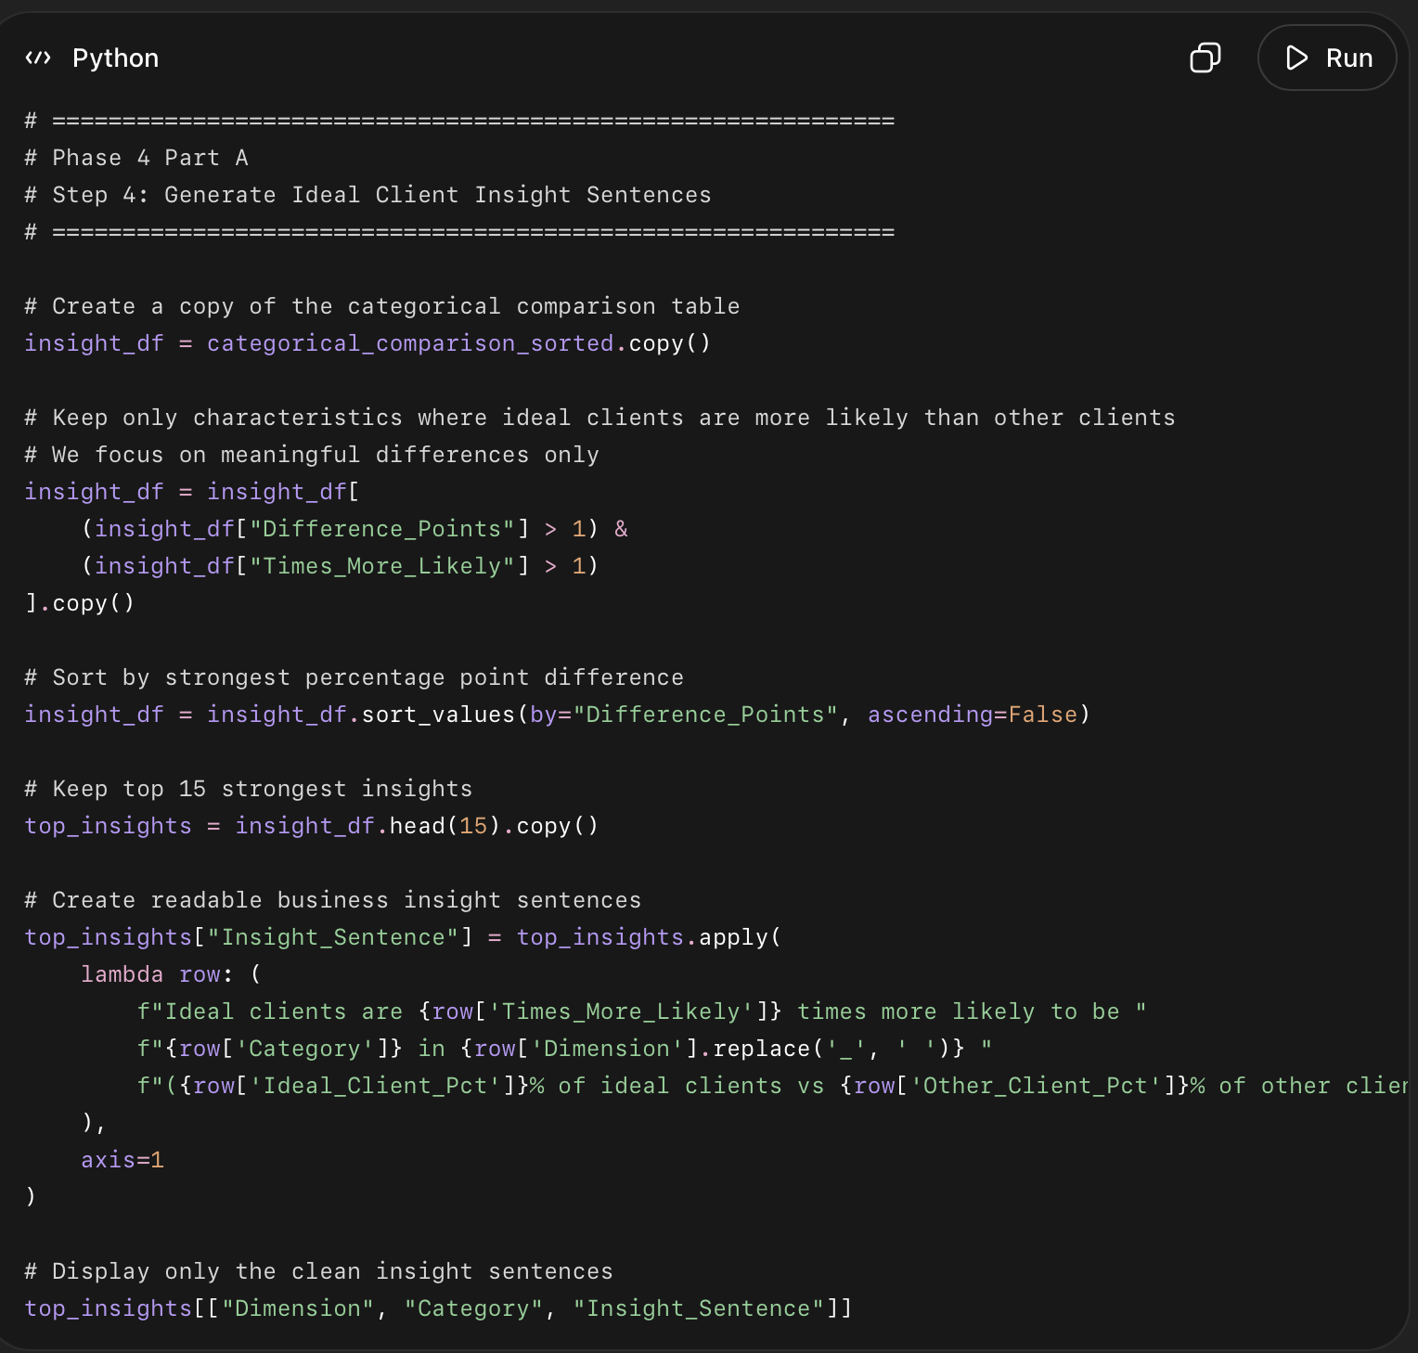

What this code does
- Uses your categorical comparison table from Step 2.
- Keeps only characteristics where ideal clients are clearly higher than other clients.
- Removes tiny or weak differences.
- Creates automatic business sentences.
- Gives you a clean table you can use in your report.

Phase 4 — Part A

Step 6: Save Ideal Client Analysis Tables
Now we’ll save your Phase 4 Part A outputs into your project folders so you can use them later in Tableau, Excel, documentation, and portfolio.
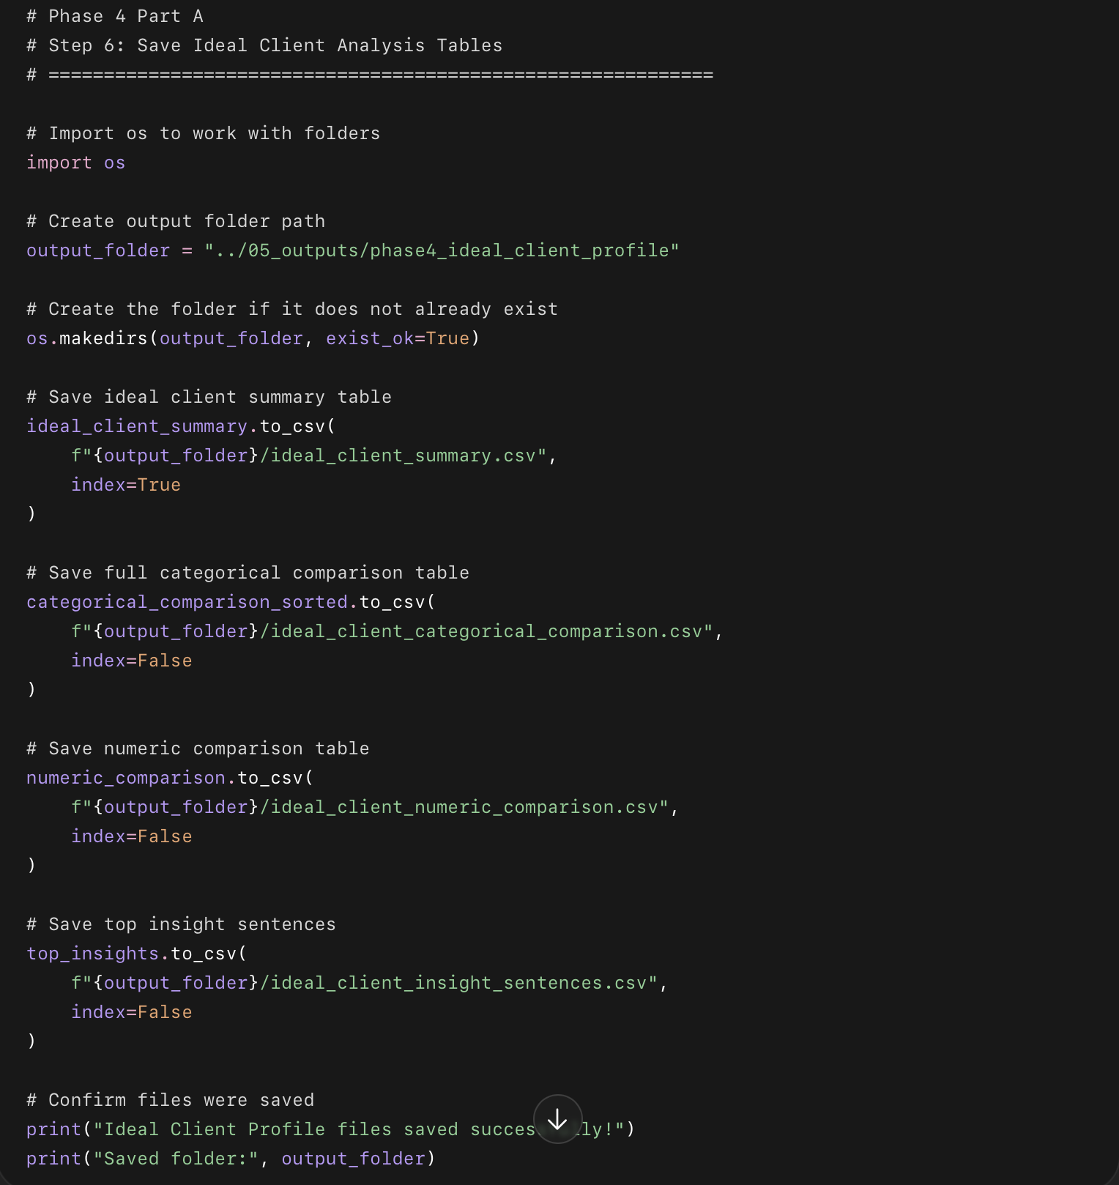

What this code does
- Creates a new folder for Phase 4 Part A outputs.
- Saves your ideal client summary table.
- Saves the categorical comparison table.
- Saves the numeric comparison table.
- Saves the insight sentences table.
- Keeps everything organized for later dashboard/report work.

Where the files will be saved
Inside your project folder:
05_outputs
└── phase4_ideal_client_profile
├── ideal_client_summary.csv
├── ideal_client_categorical_comparison.csv
├── ideal_client_numeric_comparison.csv
└── ideal_client_insight_sentences.csv

Phase 4 — Part B

Step 1: Prepare Data for K-Means Clustering
Now we prepare the exact features needed for segmentation.
We will use:
Age
Goal_Gap_kg
Checkin_Rate_Pct
Program_Duration_Days
Payment_Speed_Days
Days_To_First_Engagement
Motivation_Level_Start
Ever_Engaged
Was_Referred
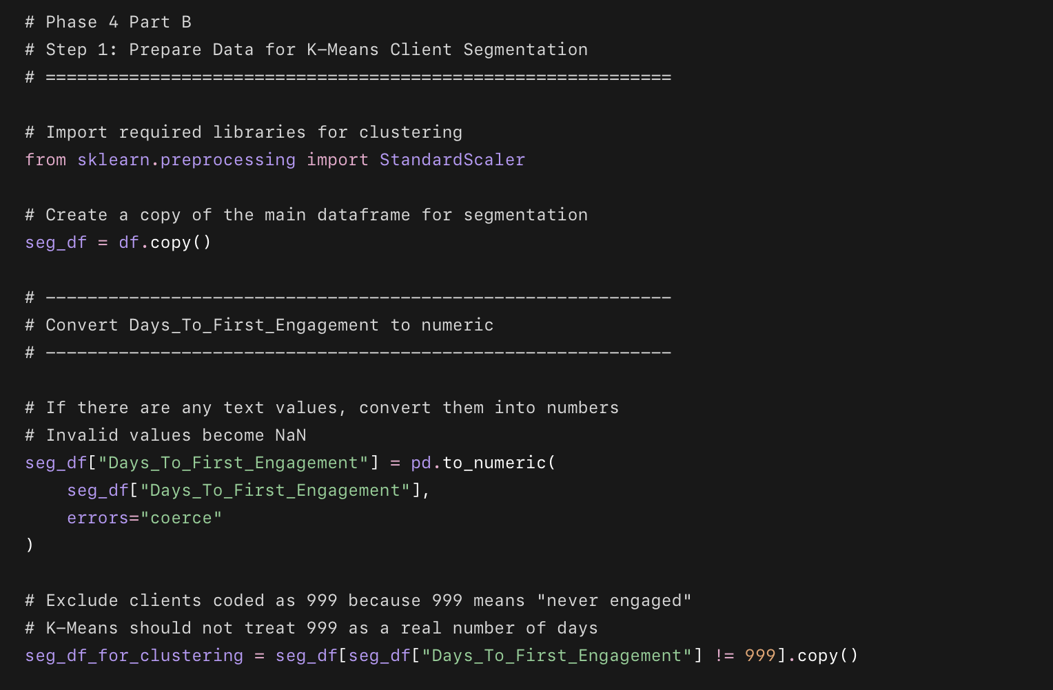
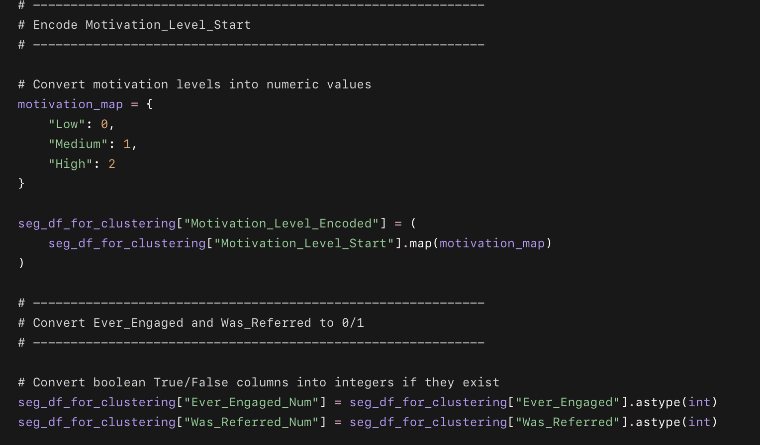
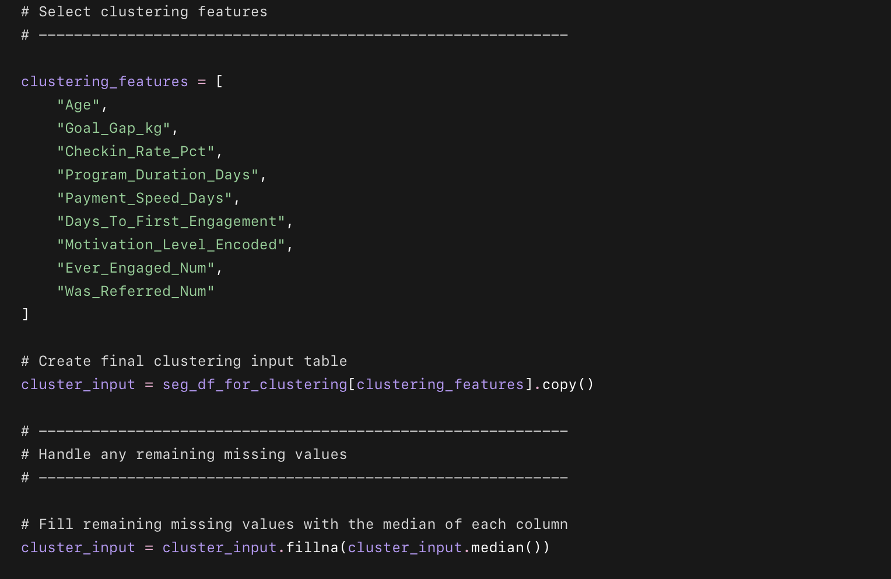
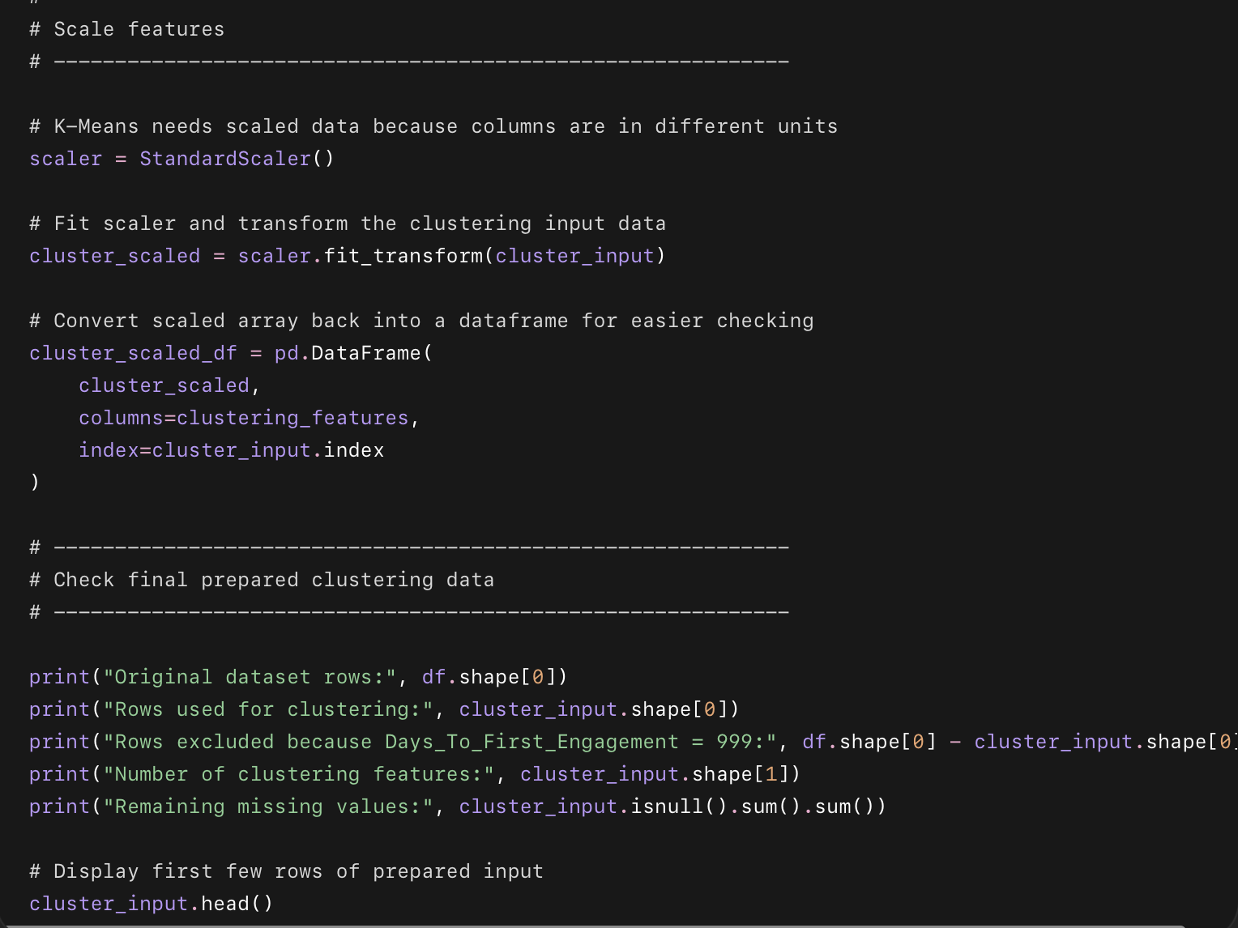

What this code does
- Creates a separate segmentation dataframe.
- Converts Days_To_First_Engagement into a number.
- Excludes 999 because that means “never engaged,” not a real day count.
- Encodes motivation:
  - Low = 0
  - Medium = 1
  - High = 2
- Converts Ever_Engaged and Was_Referred into 0/1.
- Selects the exact clustering features.
- Fills any missing values.
- Scales the data using StandardScaler.

Part B

Step 2: Elbow Curve + Silhouette Score
Now we test cluster counts from k = 2 to 10.
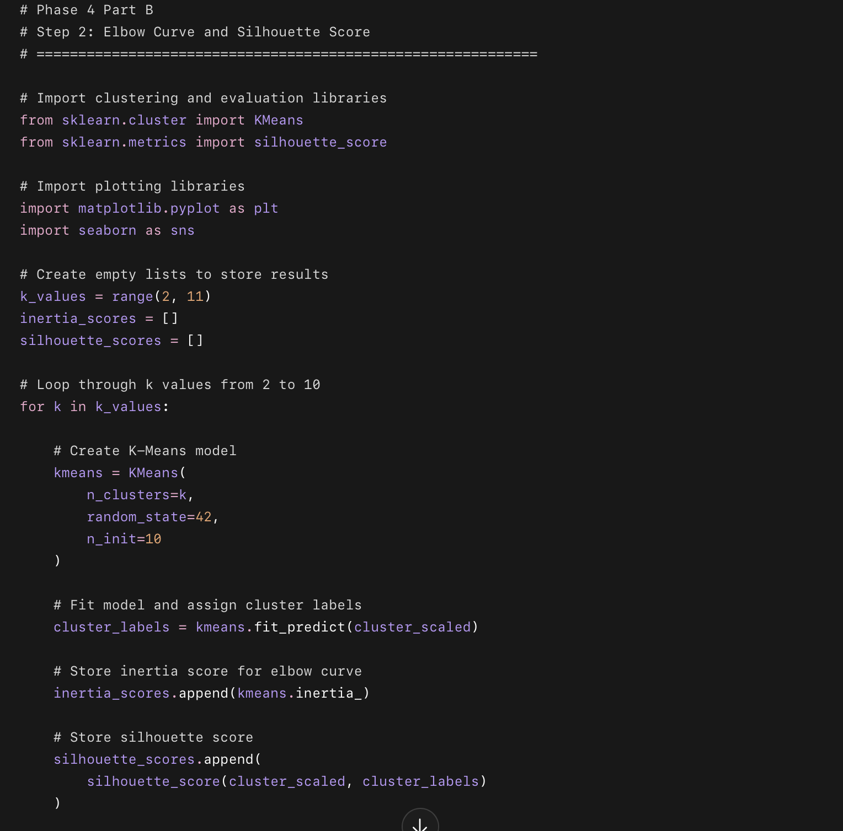
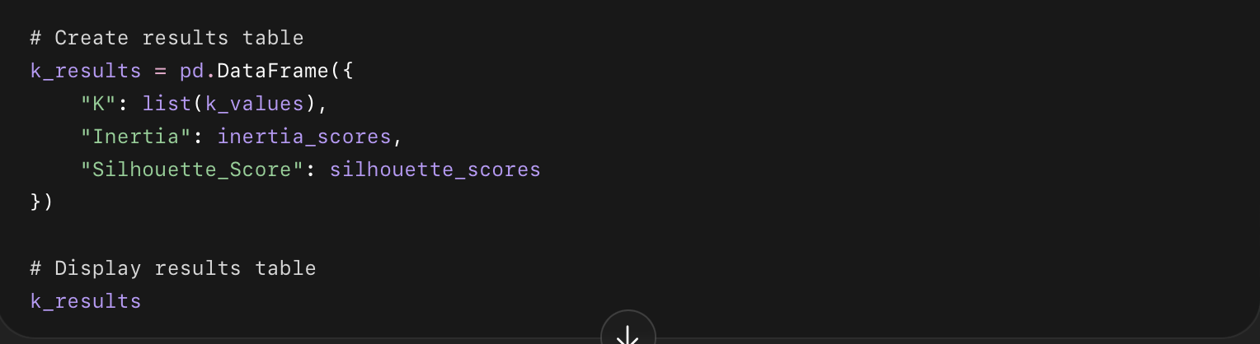
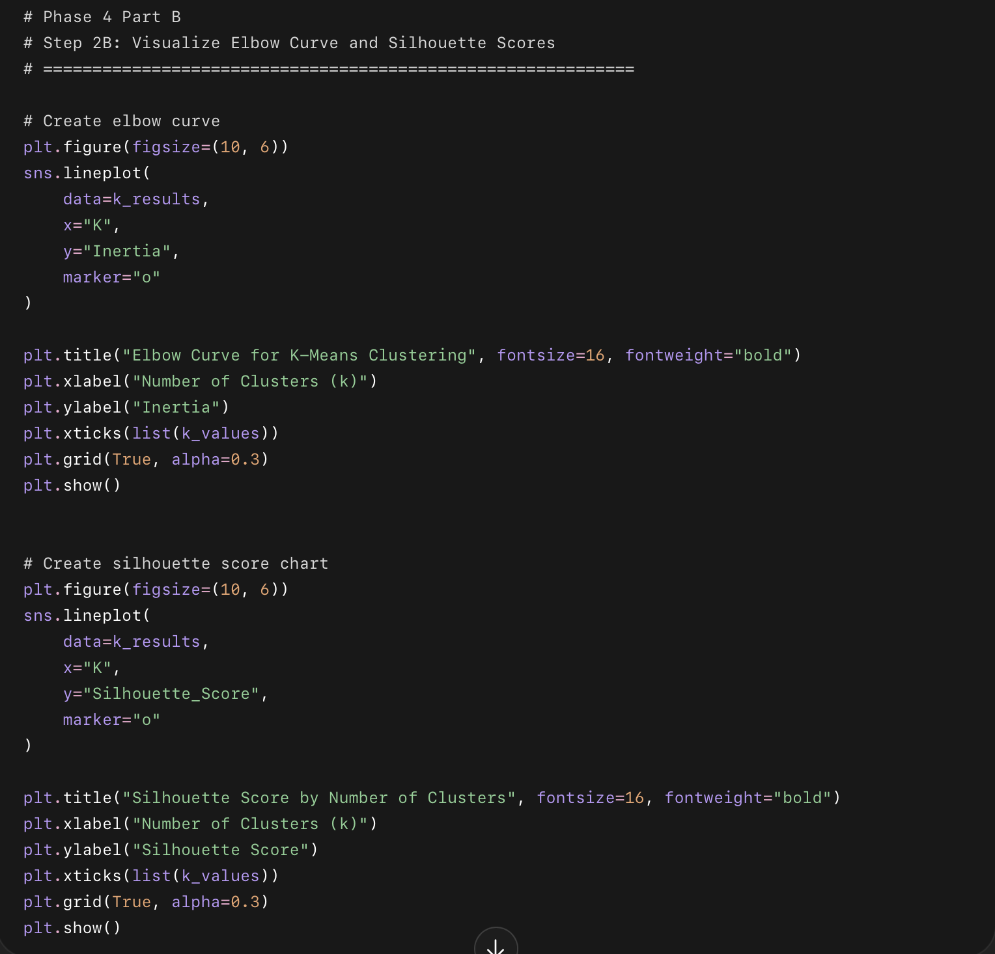

What this code does
- Tests K-Means using 2 to 10 clusters.
- Calculates inertia for the elbow curve.
- Calculates silhouette score to measure how separated the clusters are.
- Shows a results table.
- Creates two charts:
  - Elbow Curve
  - Silhouette Score Chart

How to choose k
Use this rule:
Good k = where inertia starts slowing down + silhouette score is reasonably strong
For this project, we are aiming for:
k = 4
because the business goal is to create 4 client personas.
But we still check the chart to make sure 4 is reasonable.

Phase 4 — Part B

Step 3: Run K-Means with k = 4 and Assign Cluster Labels
Now we will officially create the 4 client segments.

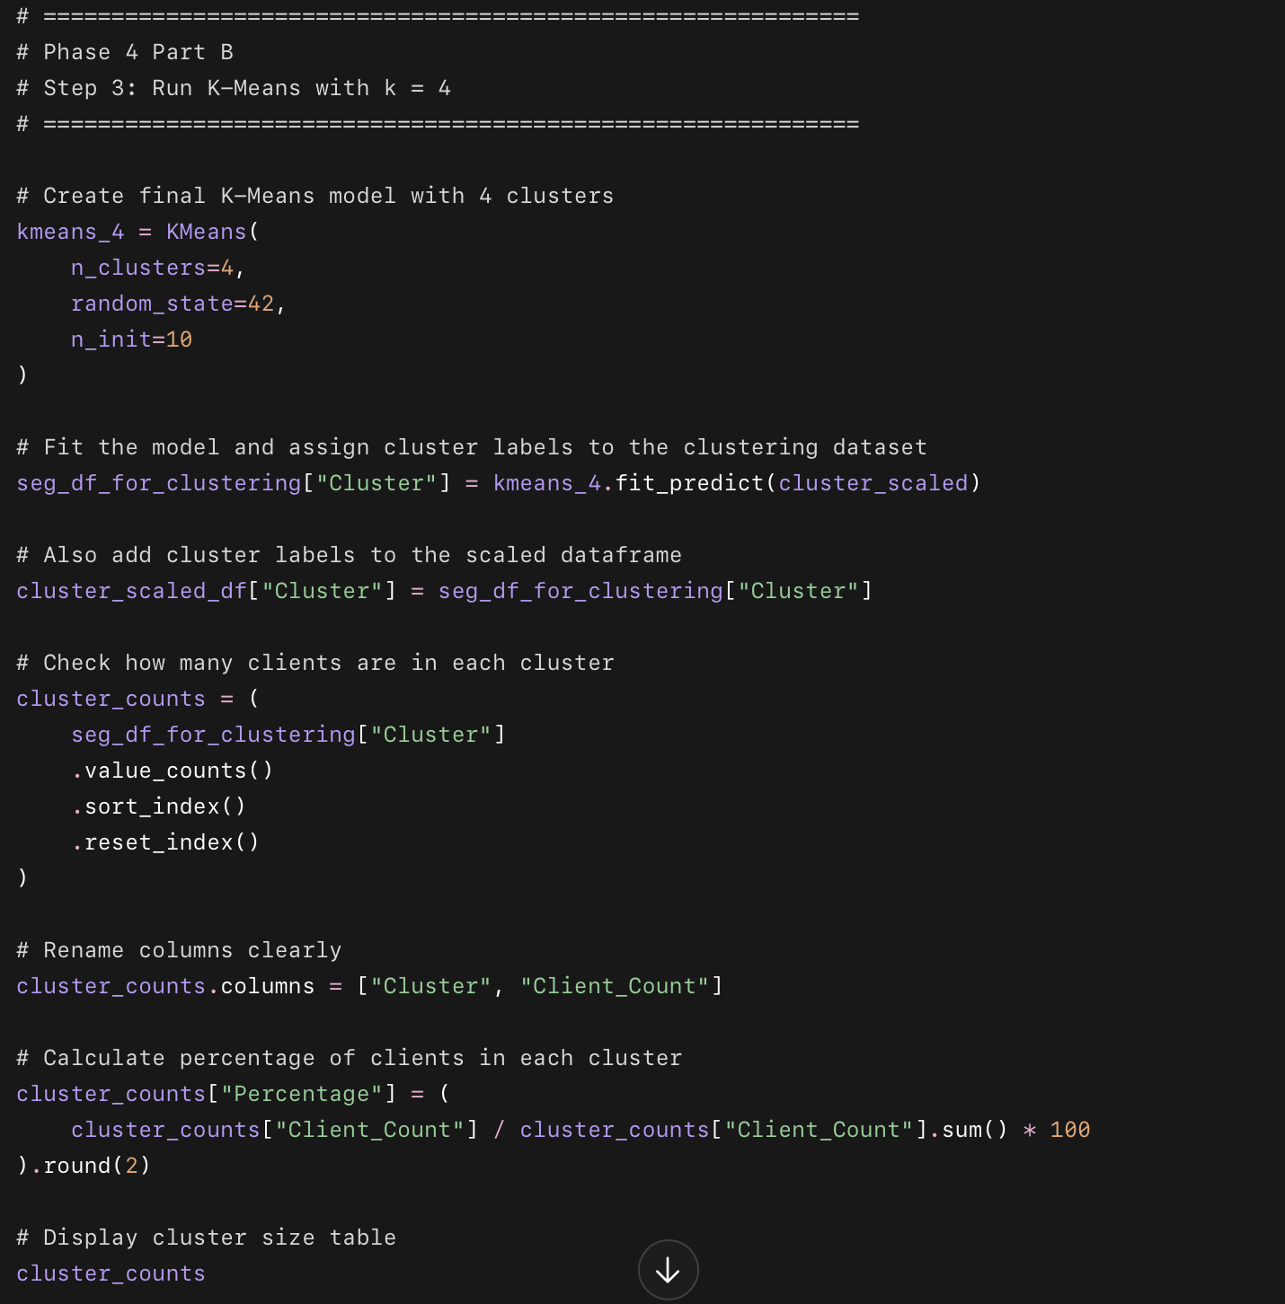 What this code does
- Runs K-Means using 4 clusters.
- Assigns each of the 2,867 clustering clients into one cluster.
- Creates a new column called:
Cluster
- Shows how many clients are in each cluster.
- Shows what percentage each cluster represents.

Phase 4 — Part B

Step 4: Profile Each Cluster
Now we’ll understand what each cluster actually means.
We will calculate:
Average age
Average goal gap
Average check-in rate
Average program duration
Average payment speed
Average days to first engagement
Average motivation level
Engagement rate
Referral rate
Completion rate
Goal achievement rate
Second round rate
Progress photo sharing rate
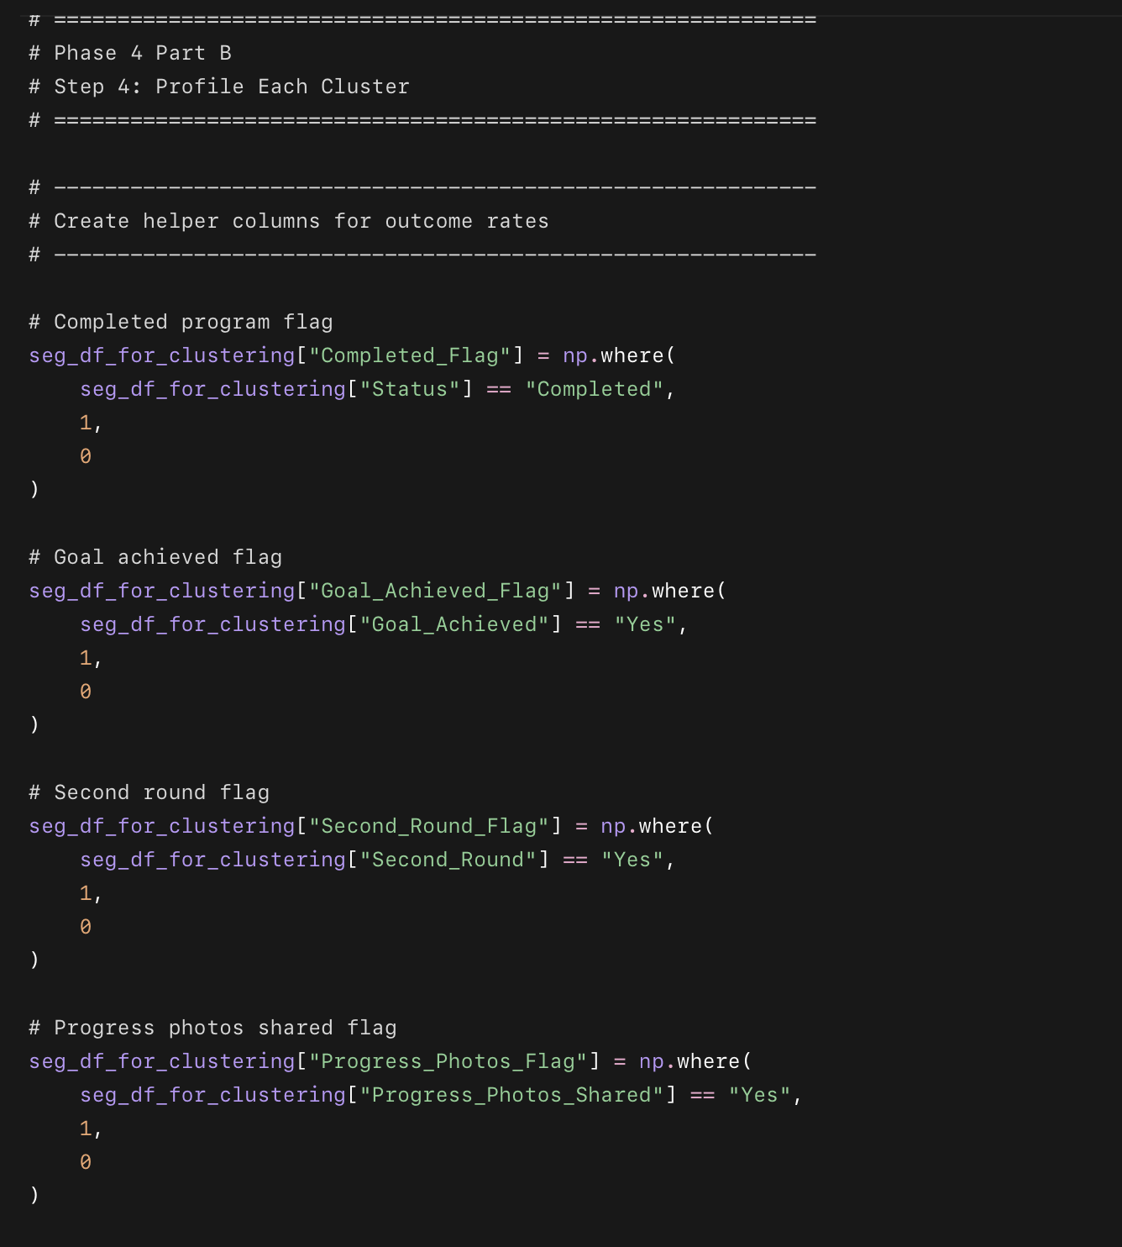
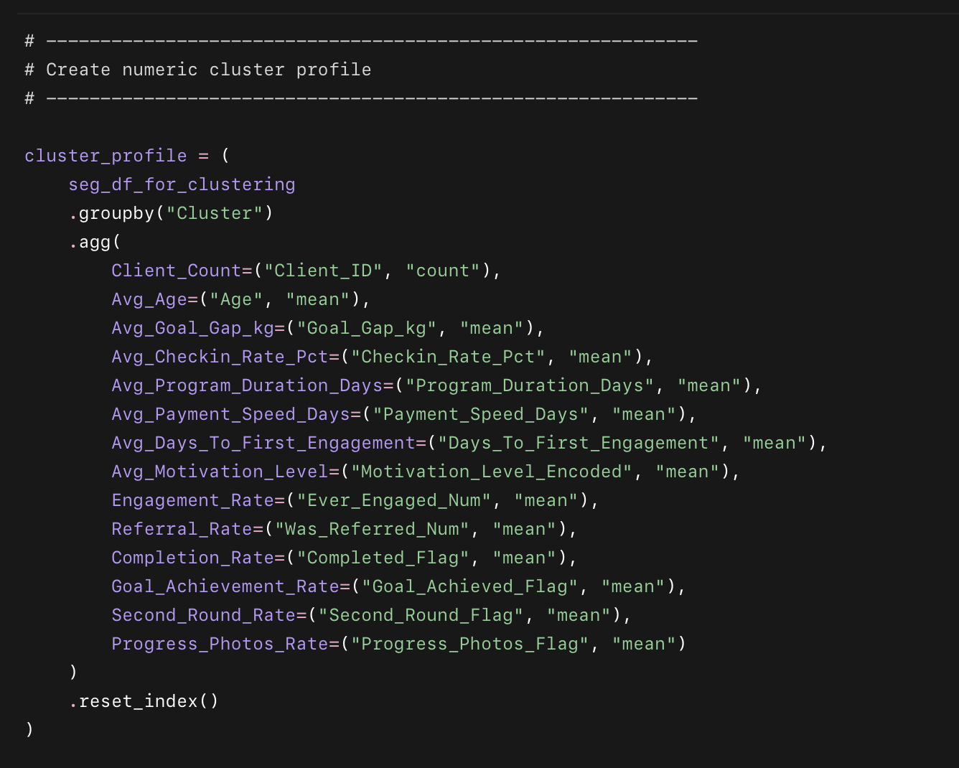
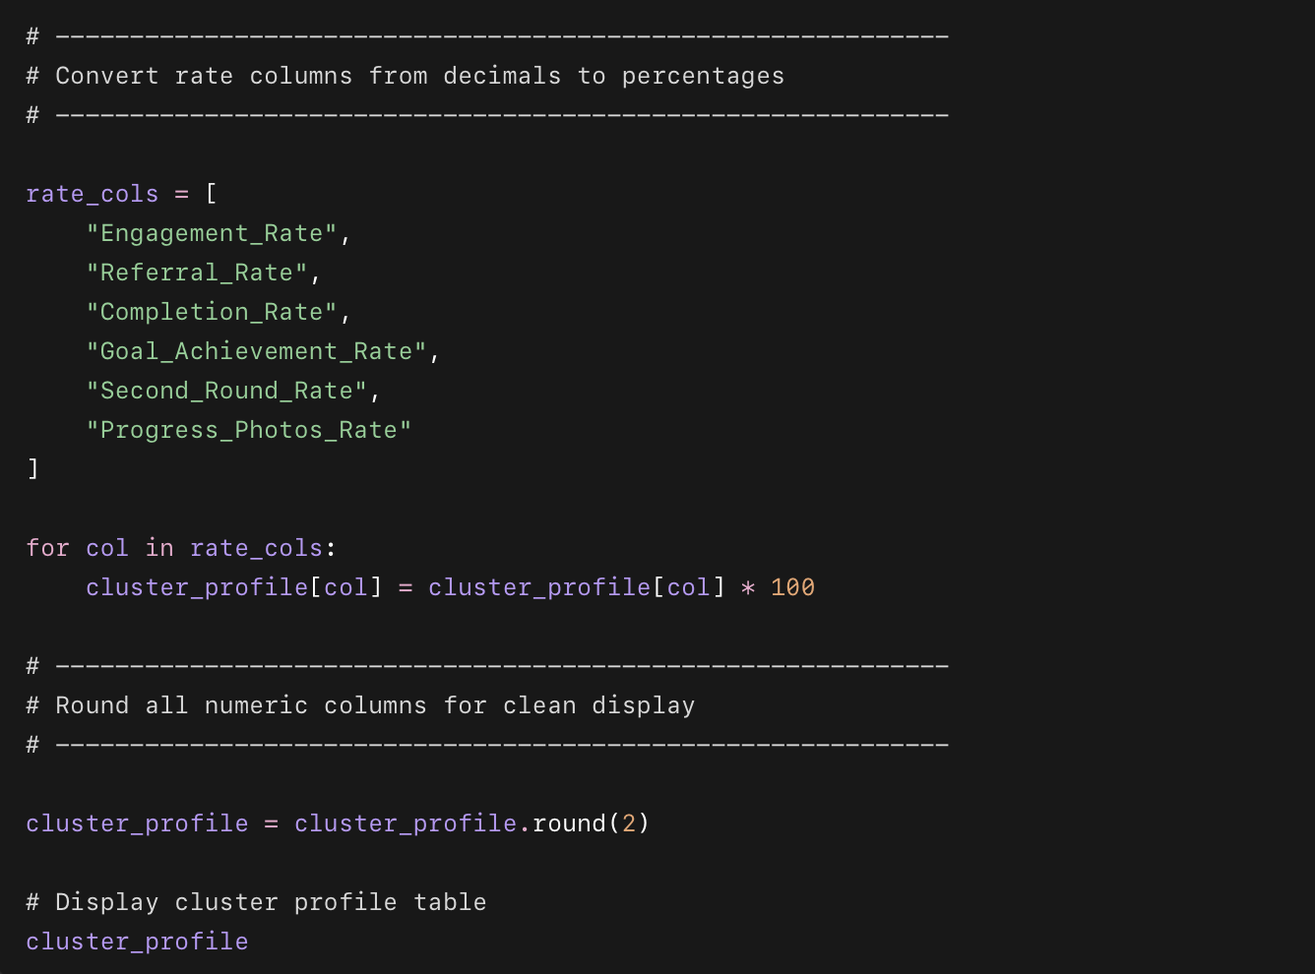

What this code does
- Adds simple 0/1 flags for important business outcomes.
- Groups clients by cluster.
- Calculates the average behavior and success rate for each cluster.
- Shows which clusters are high-performing, low-performing, engaged, referred, repeat buyers, or goal achievers.

Part B

Step 5: Name the 4 Client Personas
Now we’ll turn cluster numbers into meaningful business personas.
Based on your actual cluster profile, use these names:
Cluster 0 = The Strong Starters
Cluster 1 = The Early Drop-Offs
Cluster 2 = The Motivated Finishers
Cluster 3 = The Loyal Referrals
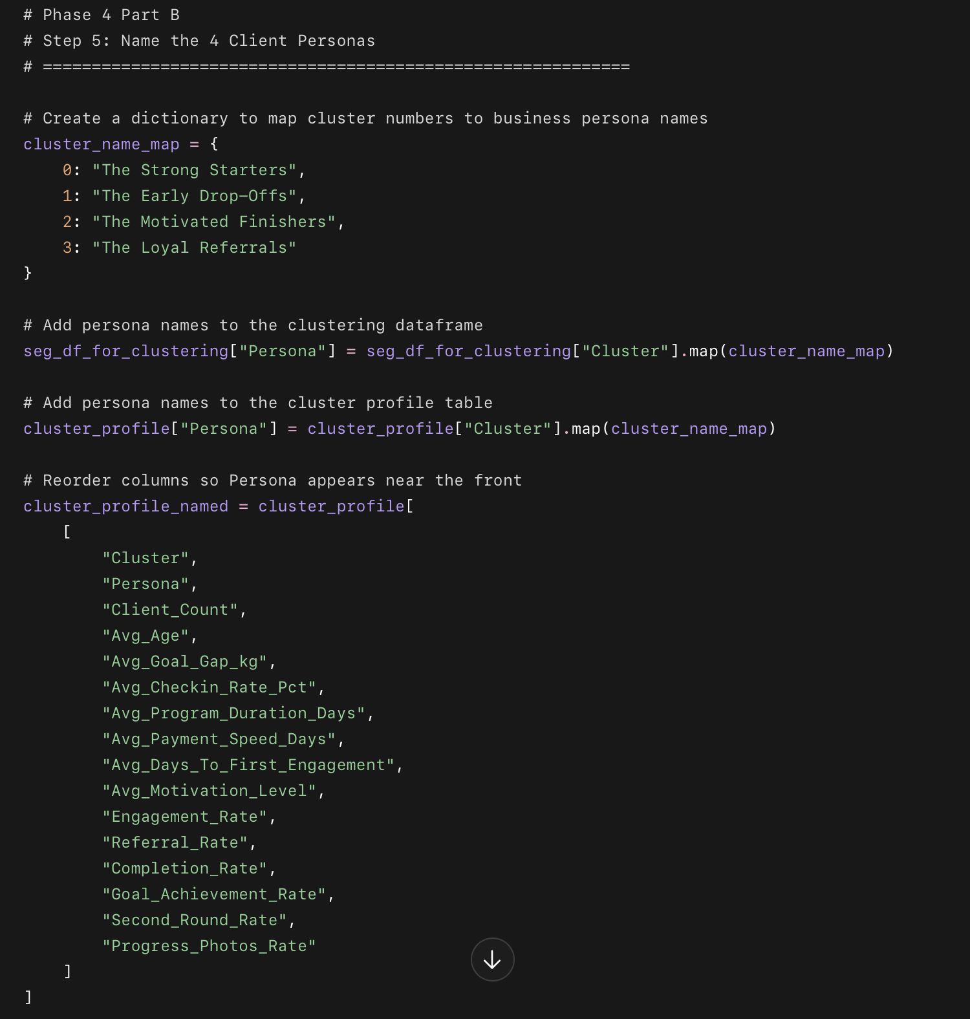
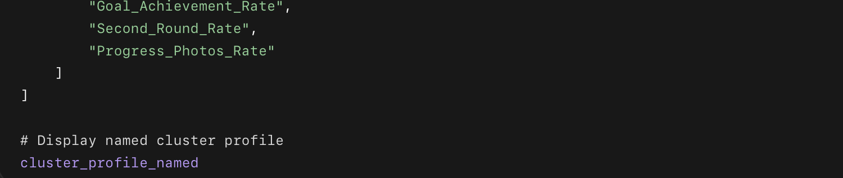

Why these names make sense

Cluster 0 — The Strong Starters
These clients perform very well, complete the program, check in often, and share progress photos. They are strong first-time clients, but they are not referral clients and do not usually do a second round.

Cluster 1 — The Early Drop-Offs
This is the risk group. They engage at least once, but have very low check-in behavior, short program duration, 0% completion rate, and 0% goal achievement rate.

Cluster 2 — The Motivated Finishers
This is the largest and strongest organic success group. They have high motivation, high check-in rate, high completion rate, and strong progress photo sharing.

Cluster 3 — The Loyal Referrals
This group comes fully from referrals, completes the program at a very high rate, shares progress photos, and has the highest second-round rate.

Phase 4 — Part B

Step 7: PCA 2D Scatter Plot Colored by Persona
Now we’ll create the first segmentation visualization.
K-Means used 9 features, so we cannot directly see the clusters in 9D. PCA reduces those features into 2 dimensions so we can visualize the client personas on a scatter plot.
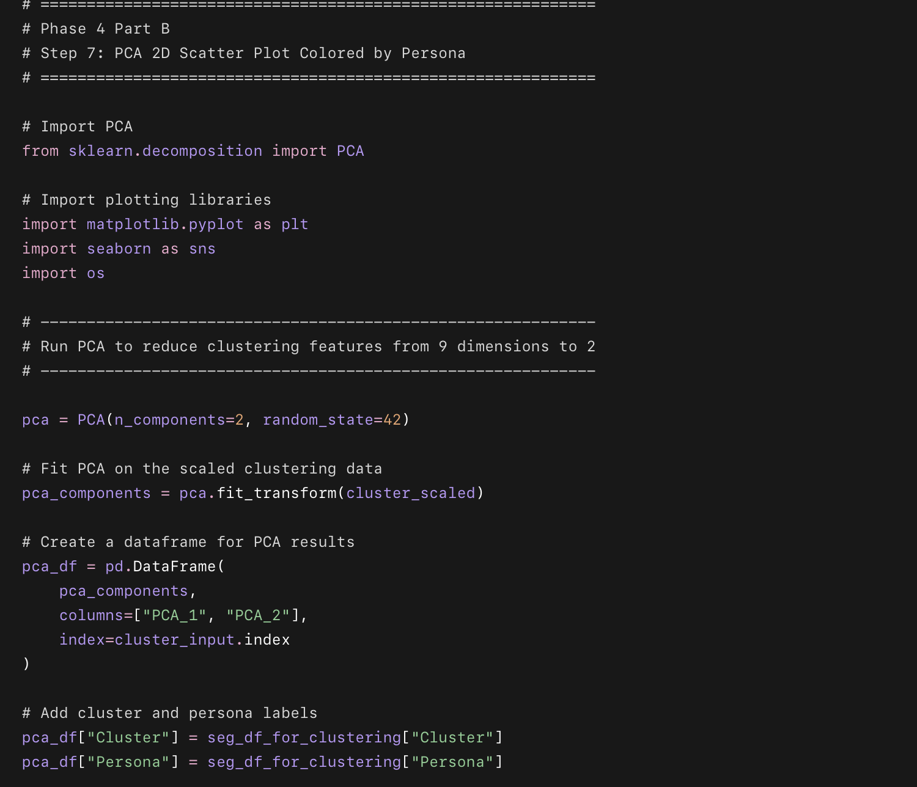
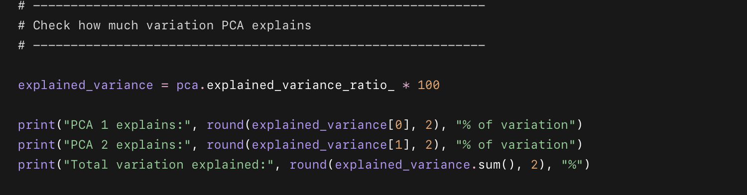
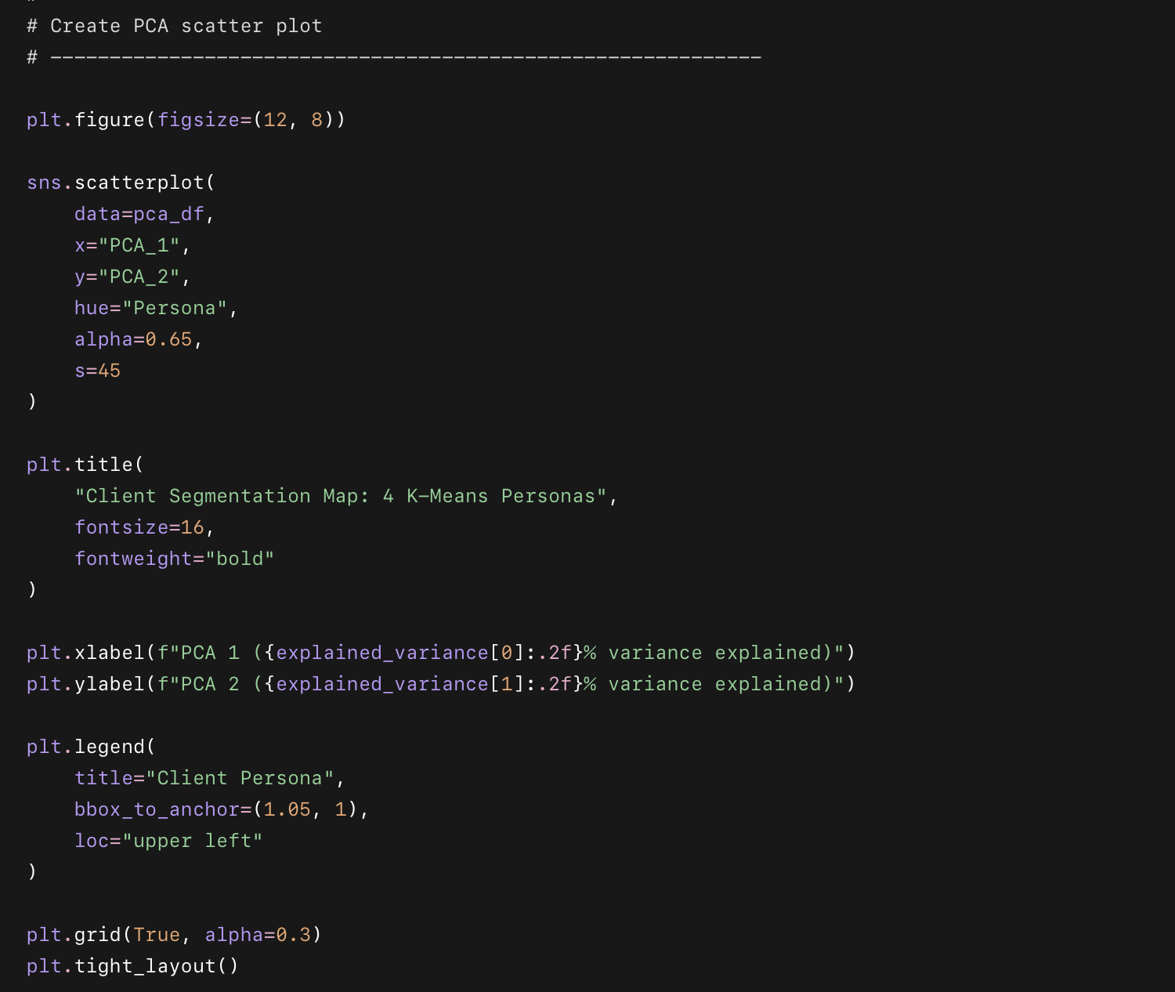
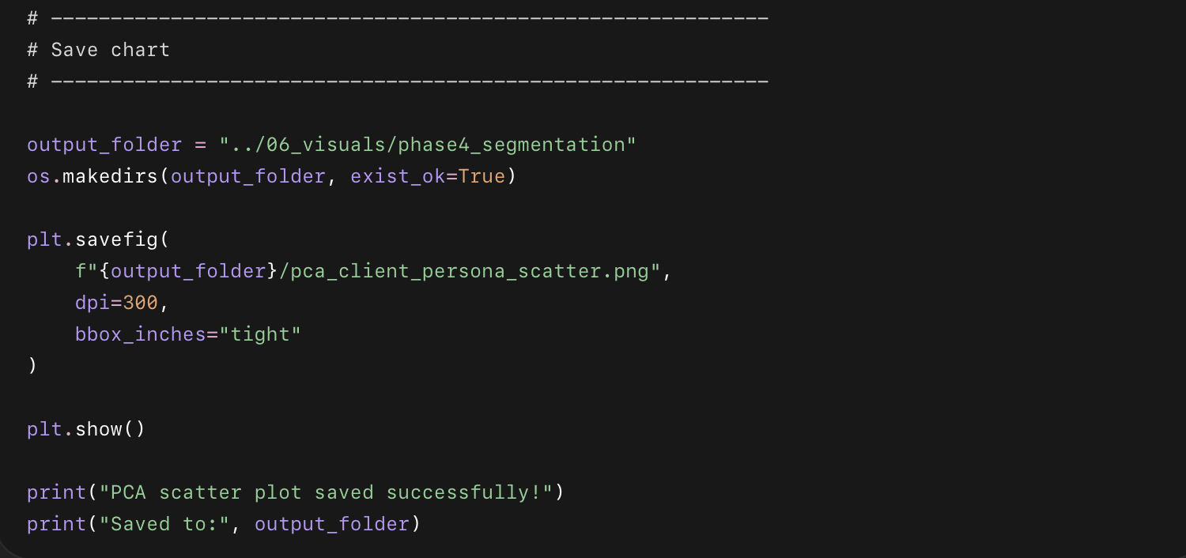

What this code does
- Uses PCA to reduce the 9 clustering features into 2 visual dimensions.
- Adds the cluster and persona names to each client.
- Creates a scatter plot where each point is one client.
- Colors each point by persona.
- Saves the chart inside:
06_visuals/phase4_segmentation

Phase 4 — Part B

Step 8: Radar Chart Comparing 4 Personas
Now we’ll create a radar chart to compare the 4 personas across 5 key dimensions:
Check-in Rate
Completion Rate
Goal Achievement Rate
Second Round Rate
Progress Photos Rate

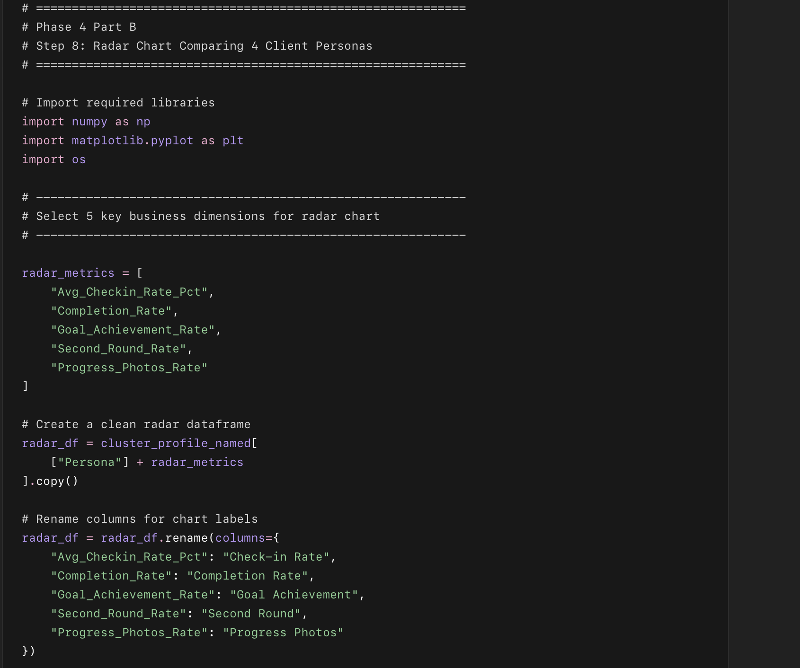
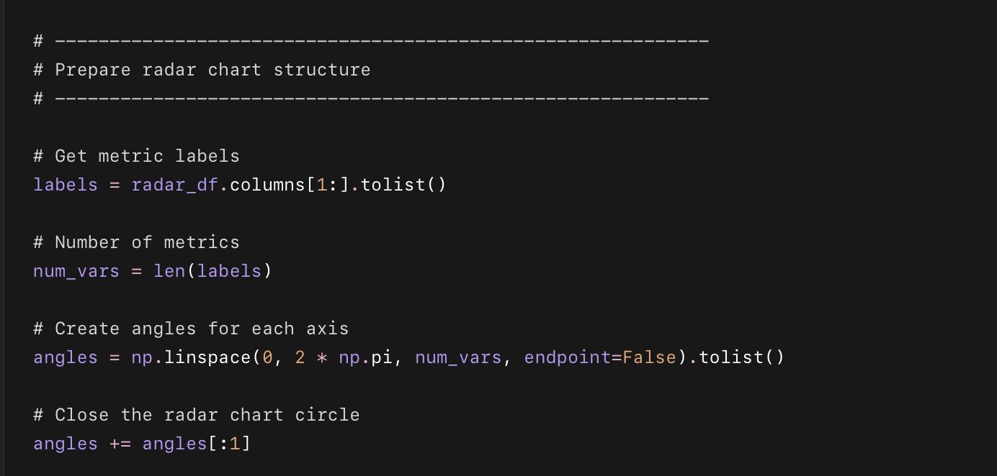
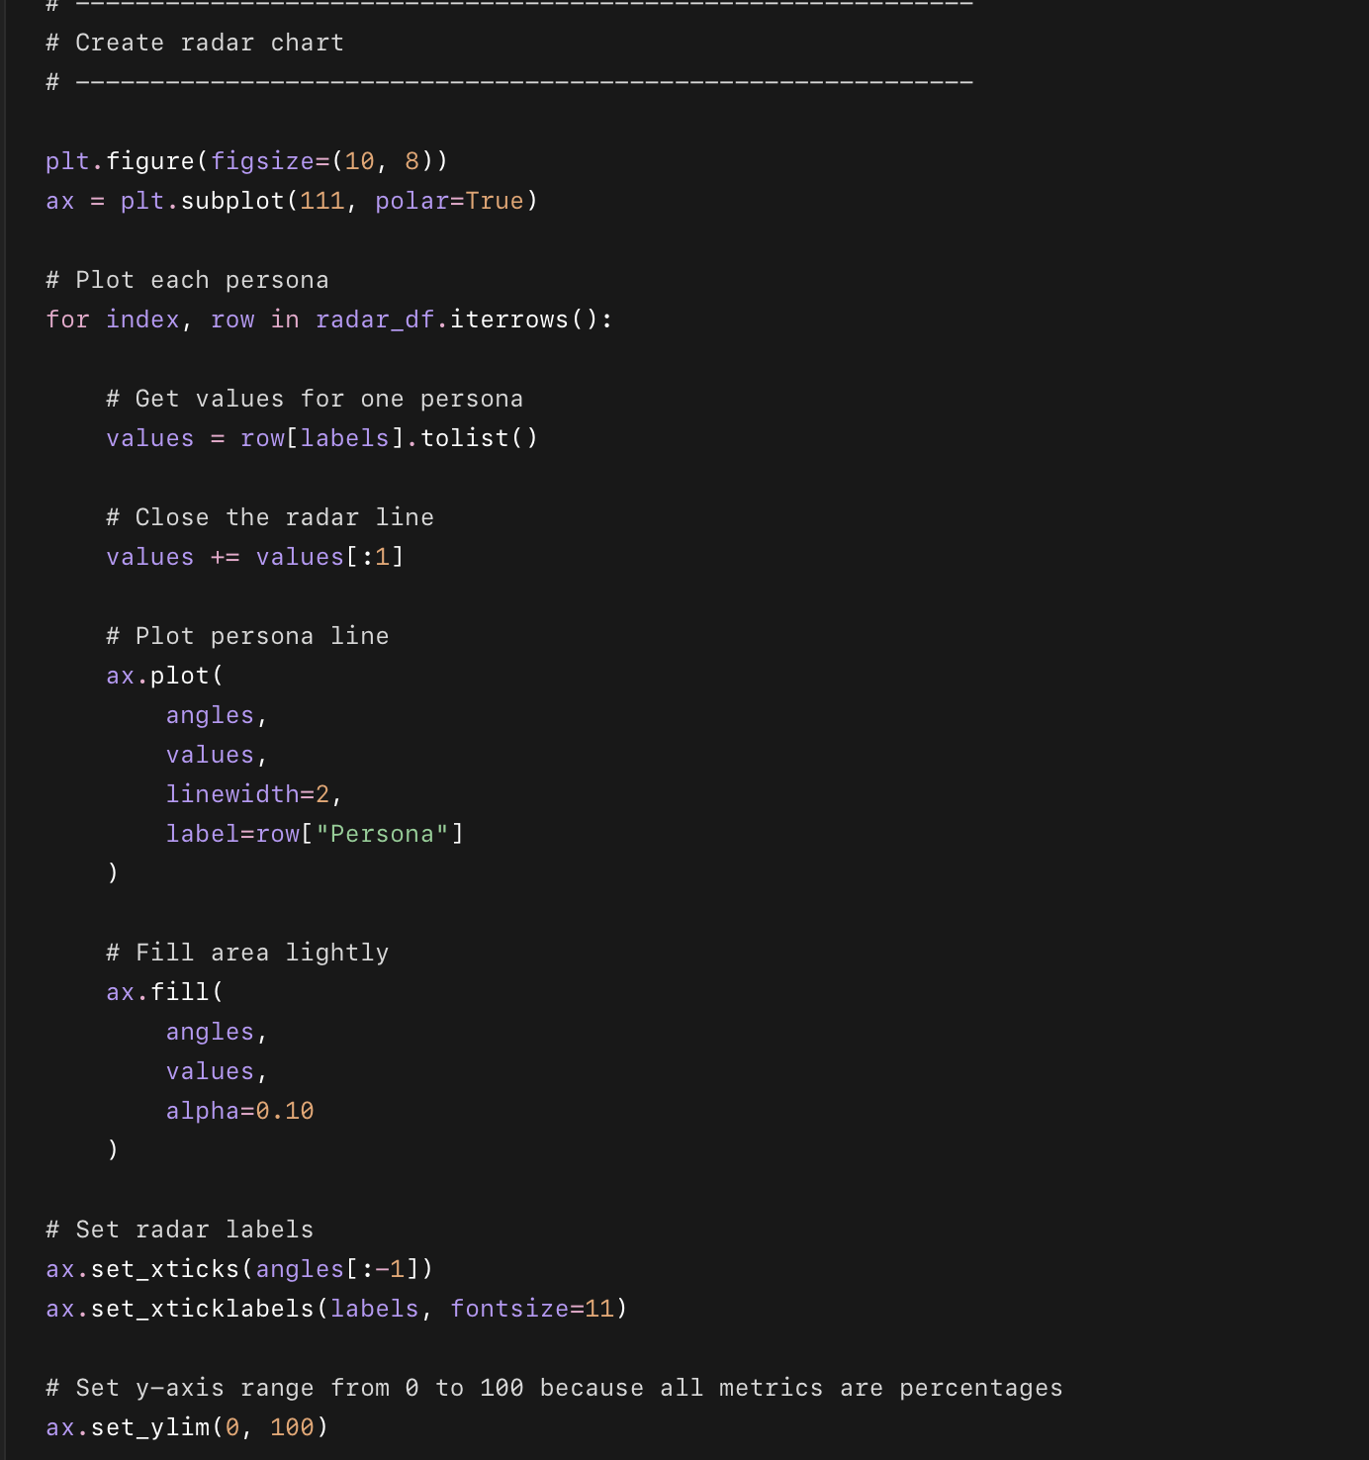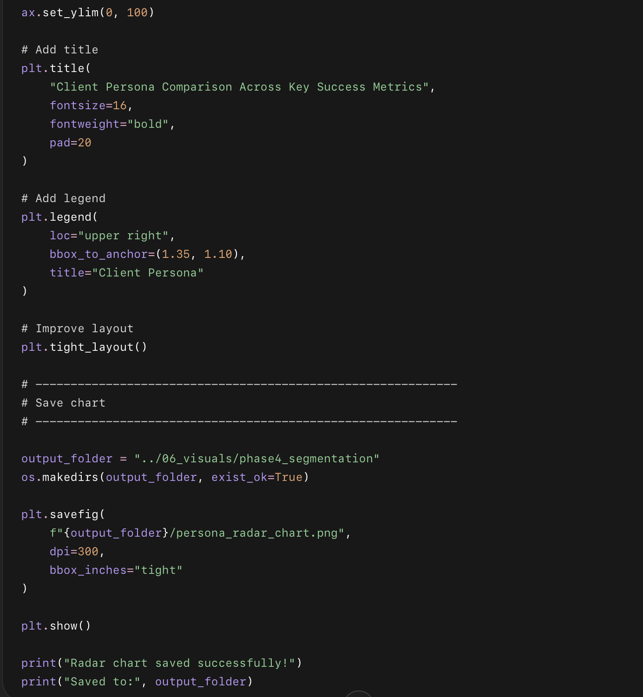

What this code does
- Takes the named cluster profile table.
- Selects 5 business success metrics.
- Creates a radar chart to compare all 4 personas.
- Shows which personas are strong or weak across success, engagement, referrals, repeat behavior, and progress tracking.
- Saves the chart in:
06_visuals/phase4_segmentation

Phase 4 — Part B

Step 9: Bar Chart — Persona Size + Completion Rate
Now we’ll create a business-friendly chart showing:
How many clients are in each persona
How successful each persona is

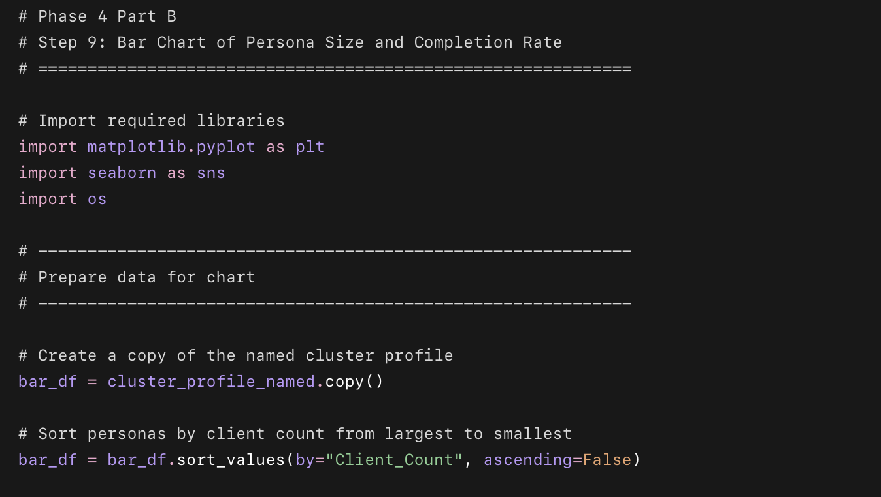
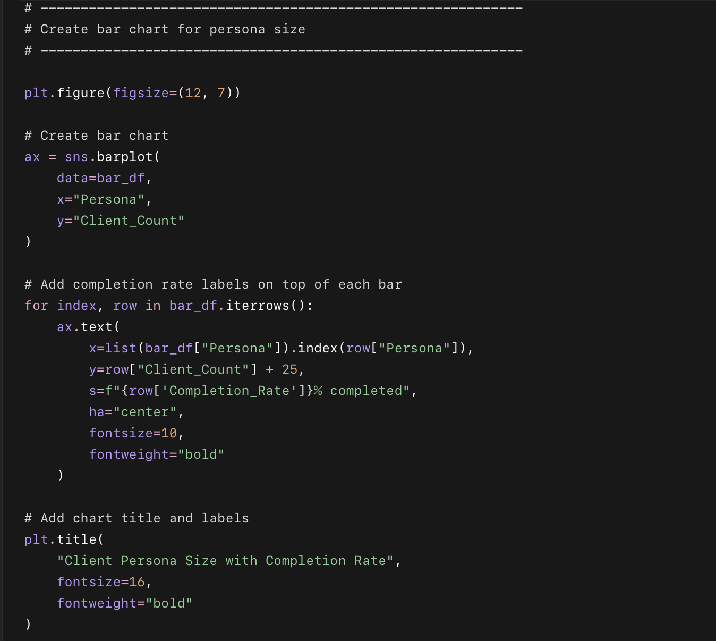
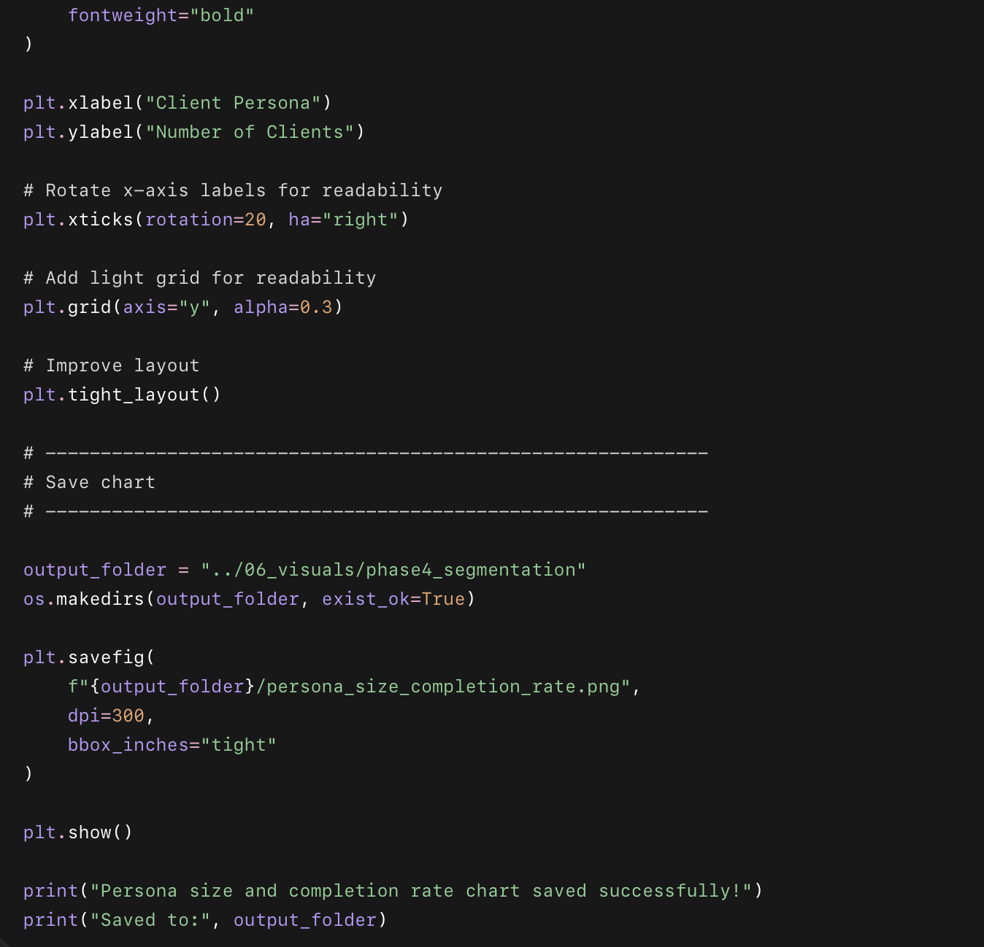

What this code does
- Uses your named cluster profile table.
- Creates a bar chart showing the size of each persona.
- Adds completion rate labels on top of each bar.
- Saves the chart in:
06_visuals/phase4_segmentation

hase 4 — Part B

Step 10: Save Segmentation Dataset + Cluster Profile Tables
Now we’ll save everything from the segmentation work so you can use it later in Excel, Tableau, documentation, and final portfolio files.

What you completed
- Prepared clustering data with 9 features
- Excluded 133 never-engaged clients coded as 999
- Scaled features using StandardScaler
- Tested k = 2 to 10 with elbow and silhouette charts
- Chose k = 4 for business-friendly personas
- Assigned cluster labels to 2,867 clients
- Profiled each cluster
- Named the personas:
  - The Strong Starters
  - The Early Drop-Offs
  - The Motivated Finishers
  - The Loyal Referrals
- Created segmentation visuals:
  - PCA scatter plot
  - Radar chart
  - Persona size + completion rate chart
- Saved all segmentation output files

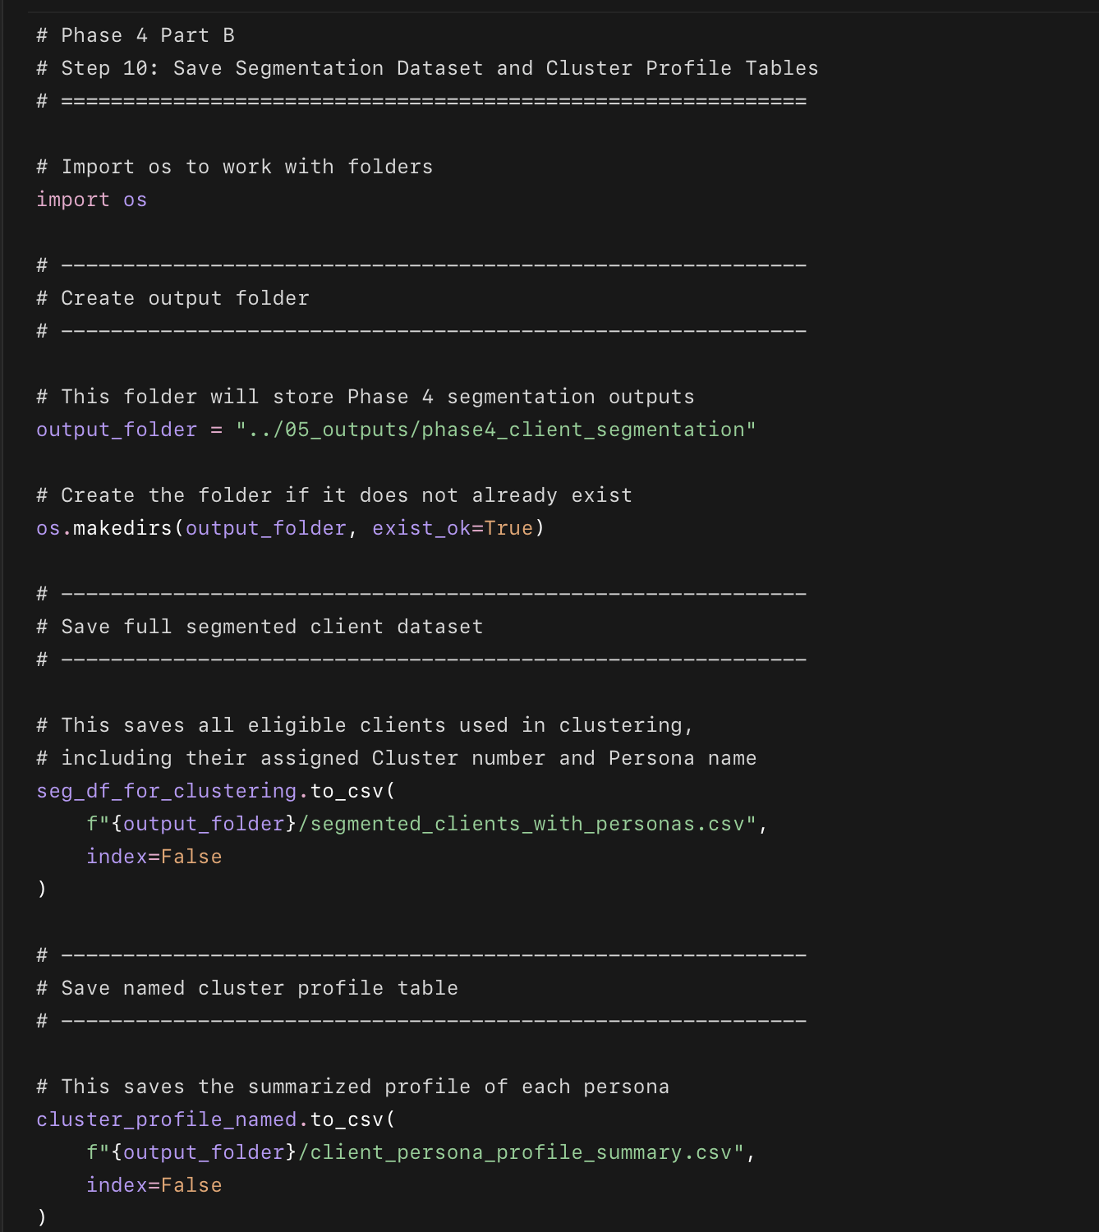
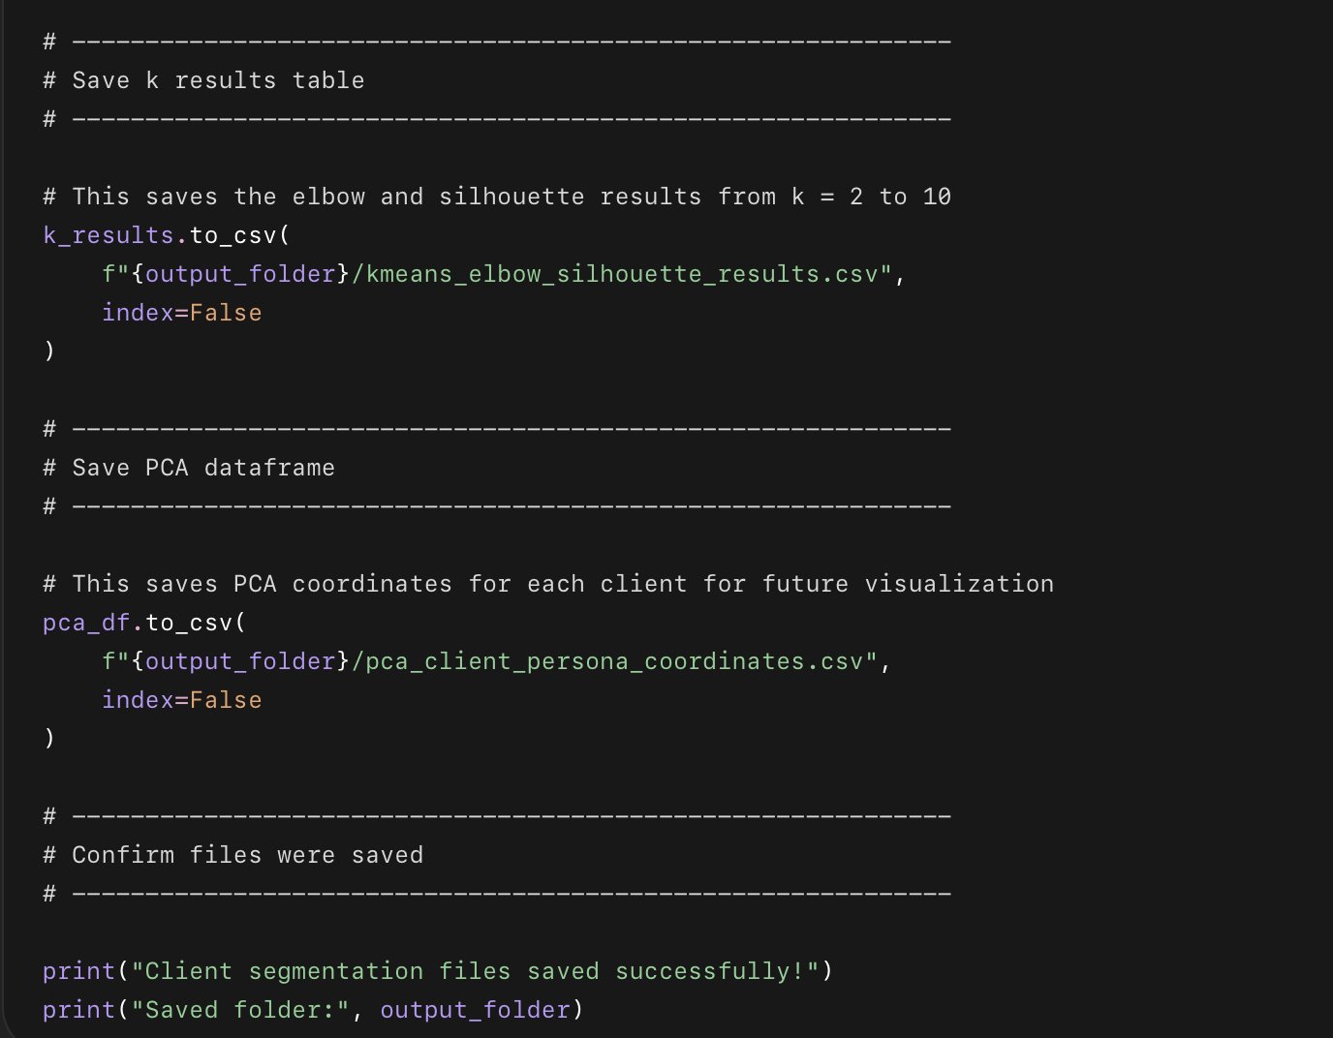

What this code does
- Creates a folder for Phase 4 segmentation outputs.
- Saves the full segmented client dataset with cluster/persona names.
- Saves the persona summary table.
- Saves the elbow and silhouette score results.
- Saves the PCA coordinates used for the scatter plot.

Files saved
05_outputs
└── phase4_client_segmentation
├── segmented_clients_with_personas.csv
├── client_persona_profile_summary.csv
├── kmeans_elbow_silhouette_results.csv
└── pca_client_persona_coordinates.csv

Phase 4 — Part C

Step 1: Compare Referred vs Non-Referred Clients
Now we’ll analyze Referral DNA.
We will compare clients who came from referrals vs everyone else on:
Completion rate
Goal achievement rate
Check-in rate
Second round rate
Whether they referred someone else

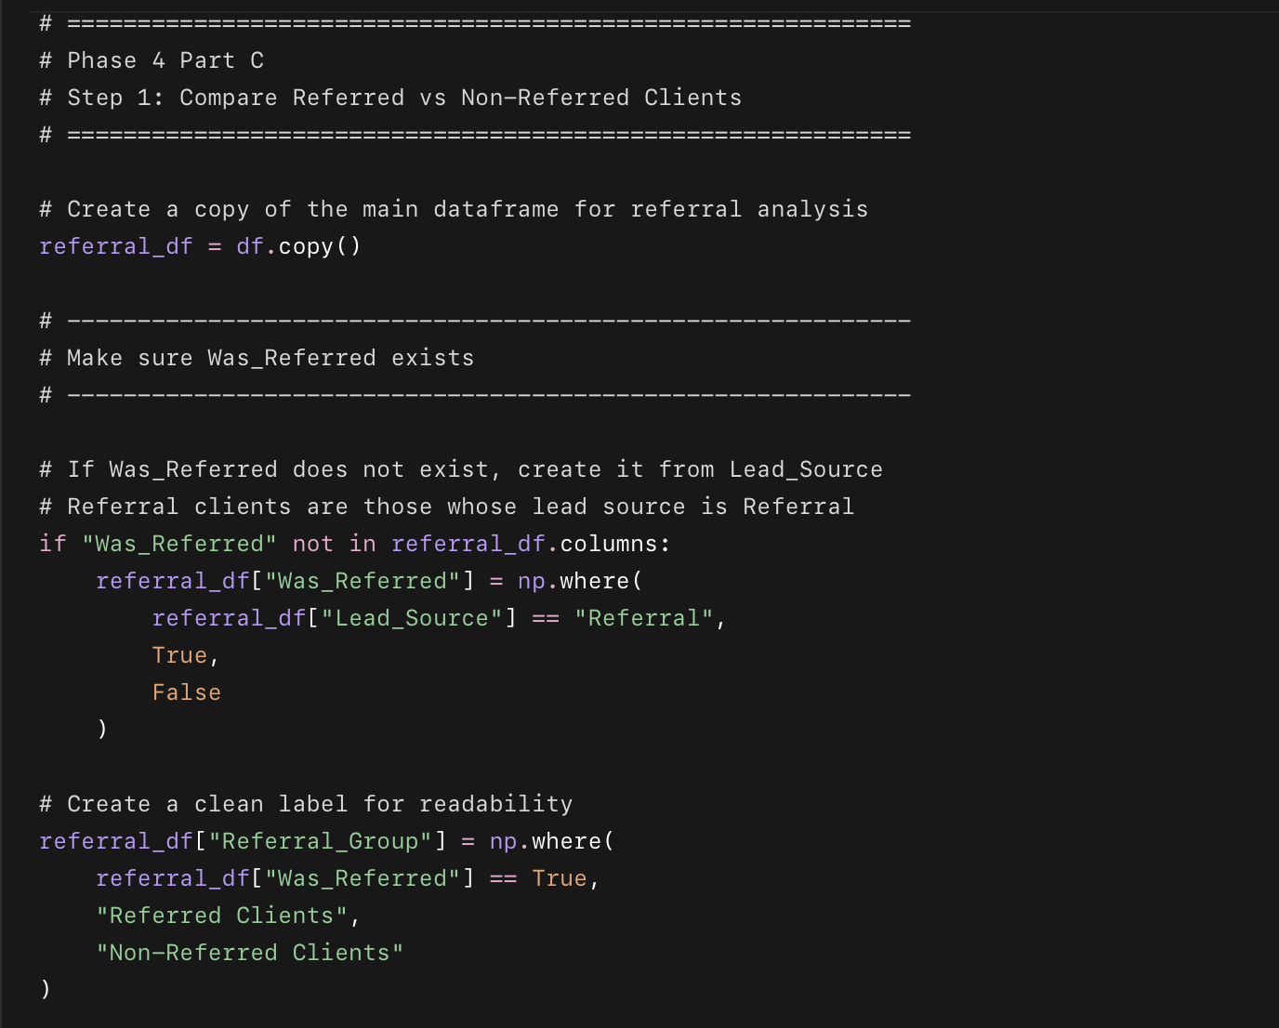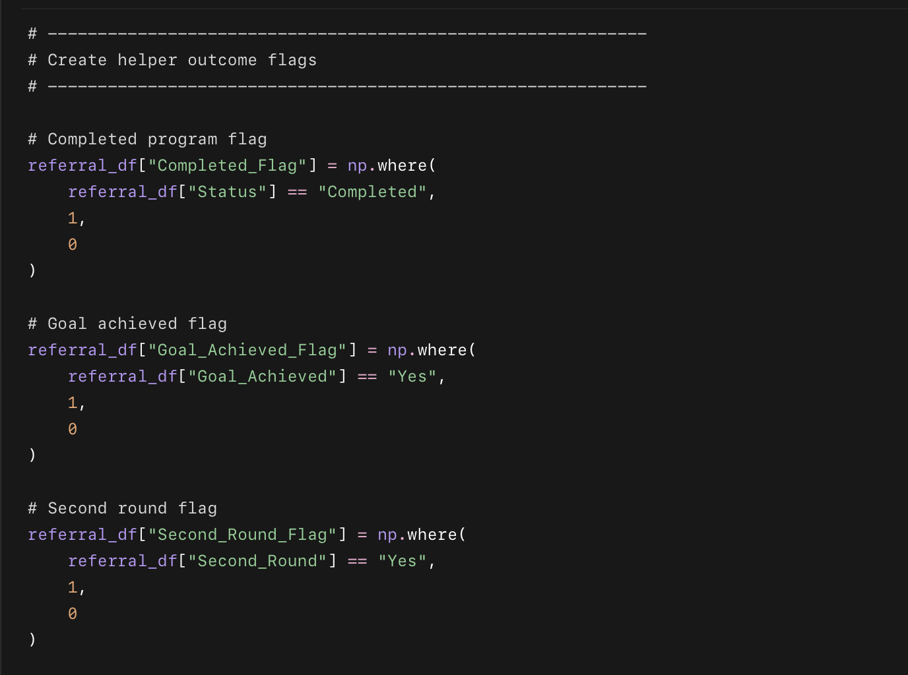
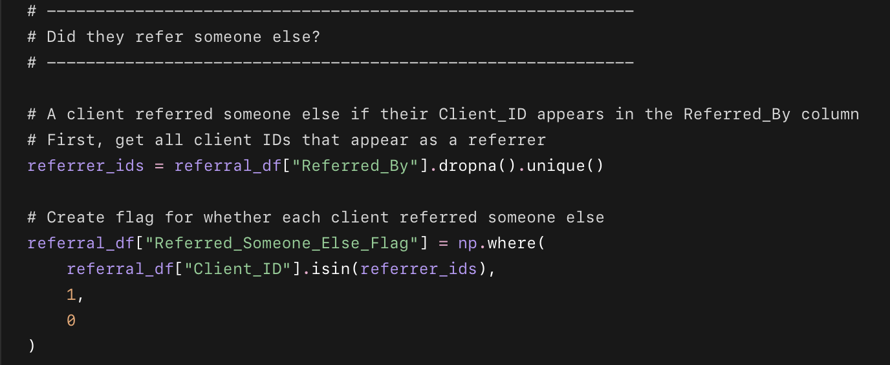
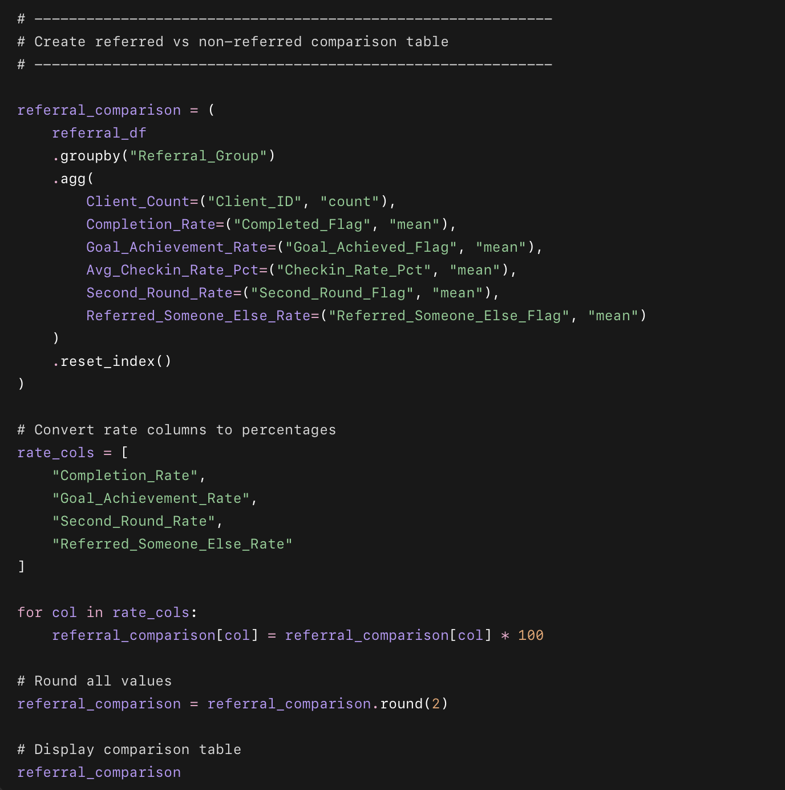

What this code does
- Separates clients into:
  - referred clients
  - non-referred clients
- Calculates completion rate for both groups.
- Calculates goal achievement rate for both groups.
- Calculates average check-in rate.
- Calculates second-round rate.
- Checks whether clients referred someone else later.
- Creates a clean comparison table.

Phase 4 — Part C step 2
Calculate refereal lift

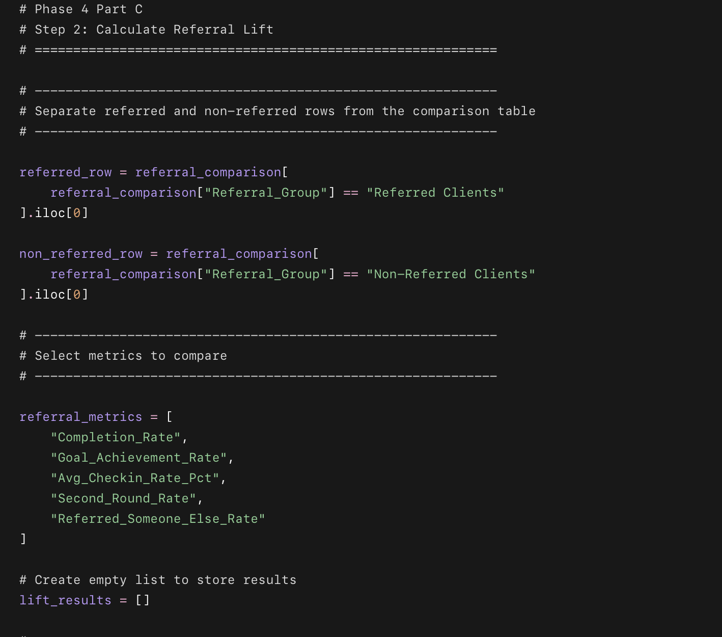
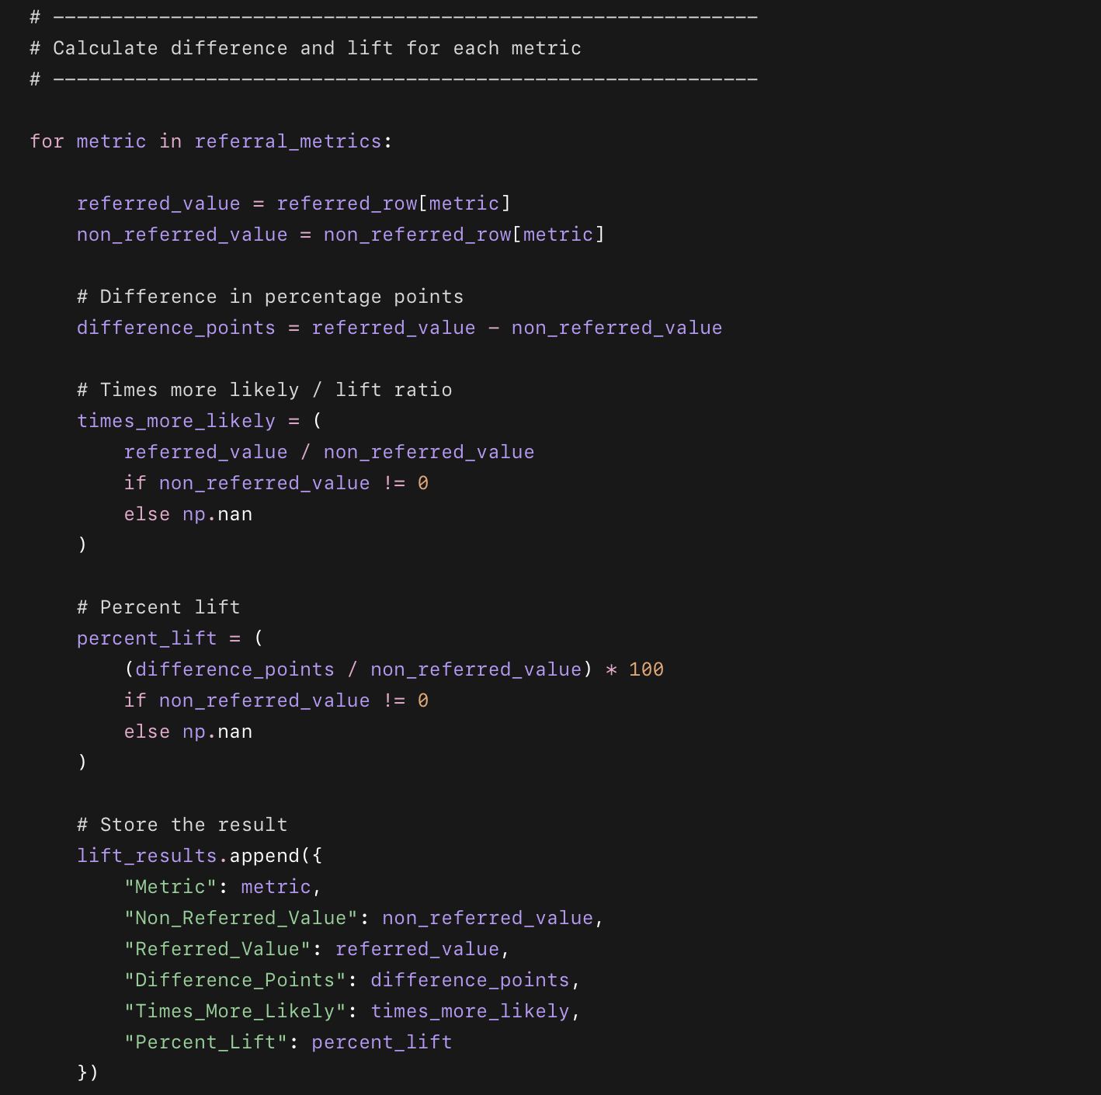
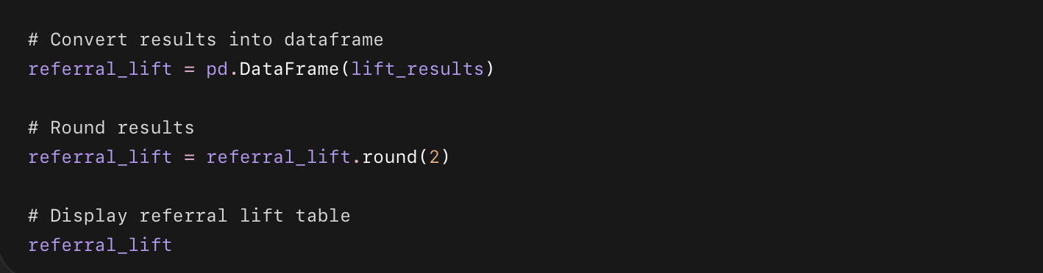

What this code does
- Takes the referred vs non-referred comparison table from Step 1.
- Calculates:
  - difference in percentage points,
  - times more likely,
  - percent lift.
- Shows exactly where referral clients outperform non-referral clients.

Phase 4 — Part C

Step 3: Estimate New Clients from a 10% Referral System
Now we’ll calculate:
If every completed client had a 10% chance of referring 1 new client,
how many new clients could Drishti generate per year?
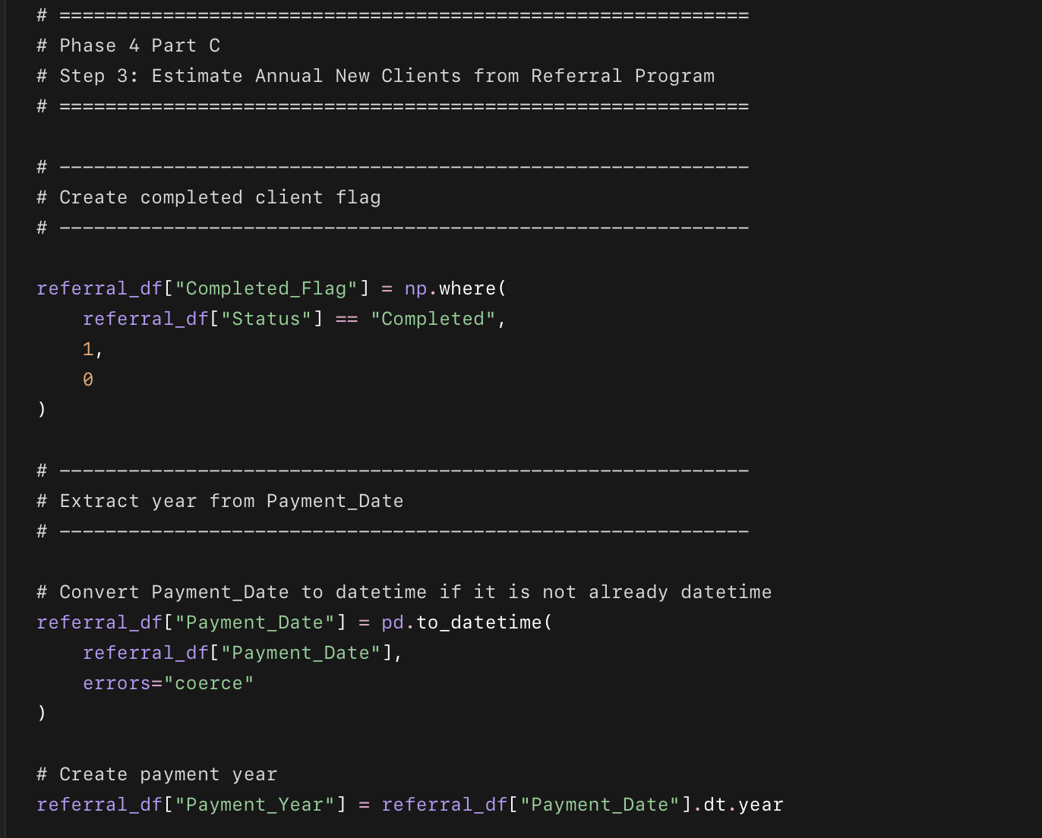
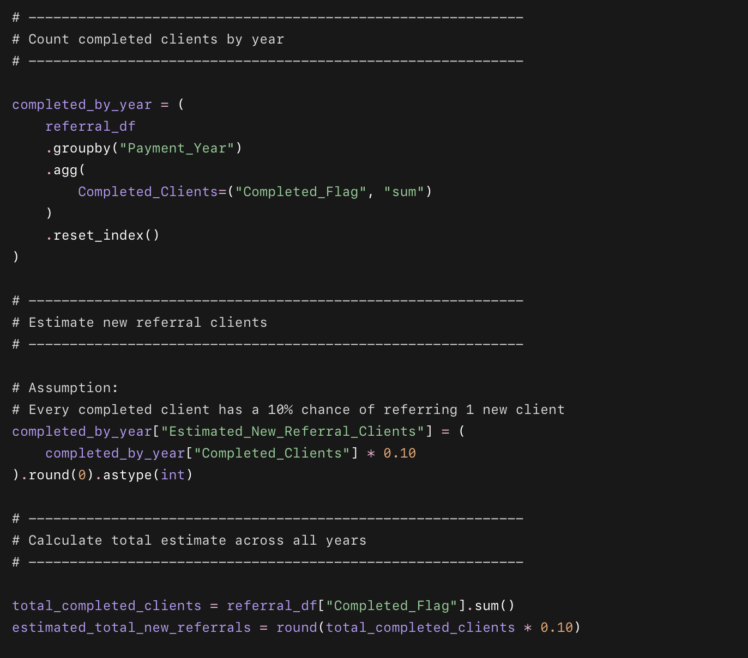
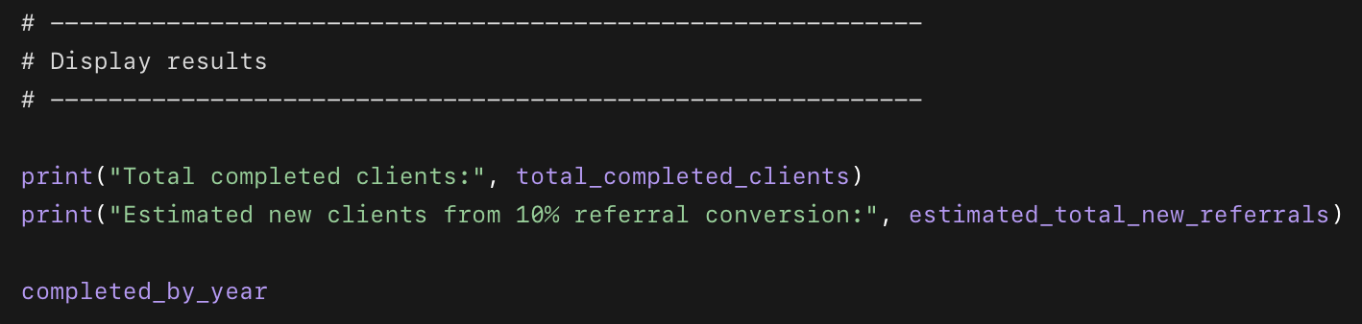

What this code does
- Counts how many clients completed the program.
- Extracts the year from Payment_Date.
- Counts completed clients per year.
- Assumes 10% of completed clients refer one new client.
- Estimates how many new clients that would generate per year.

Phase 4 — Part C

Step 5: Save Referral DNA Tables
Now we’ll save the Referral DNA outputs so you can use them later in Excel, Tableau, documentation, and your final portfolio report.
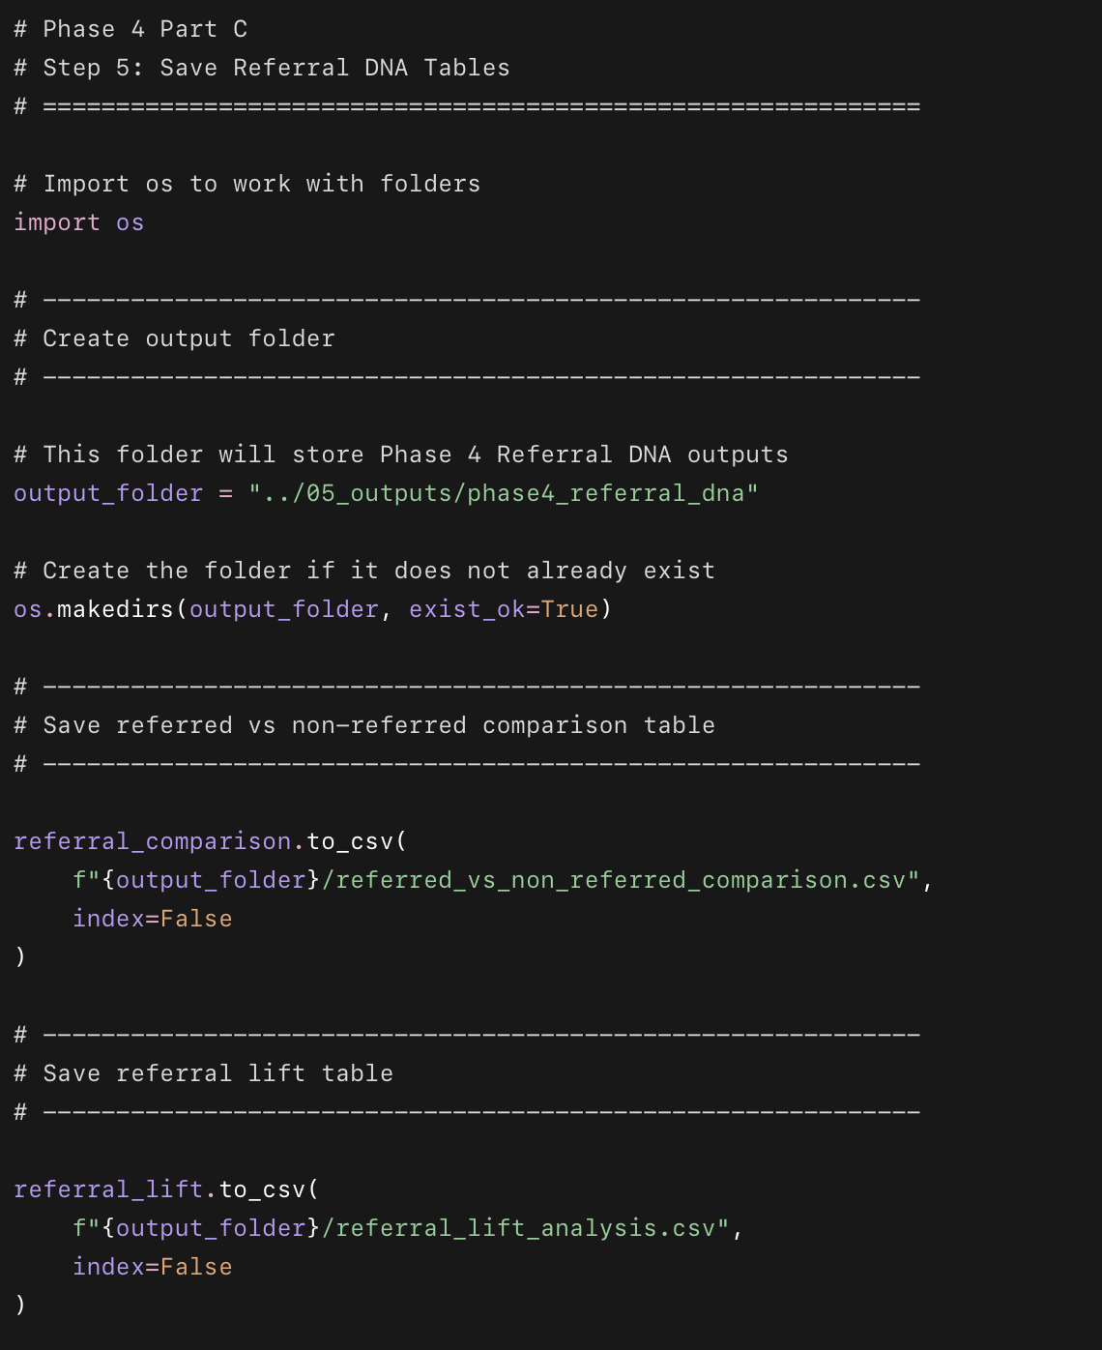
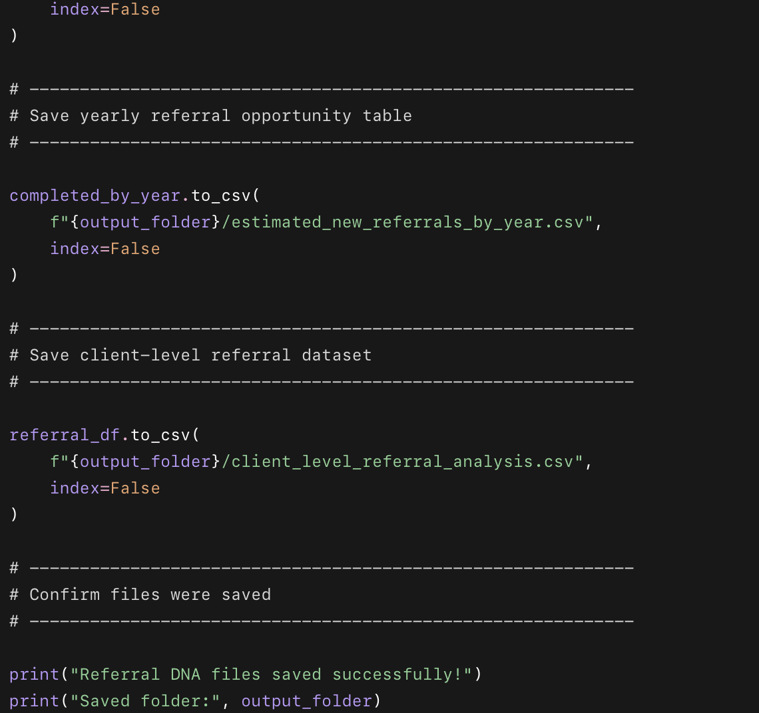

What this code does
- Creates a new folder for Referral DNA outputs.
- Saves the referred vs non-referred comparison table.
- Saves the referral lift table.
- Saves the yearly referral opportunity estimate.
- Saves the client-level referral analysis dataset.

Files saved
05_outputs
└── phase4_referral_dna
├── referred_vs_non_referred_comparison.csv
├── referral_lift_analysis.csv
├── estimated_new_referrals_by_year.csv
└── client_level_referral_analysis.csv

